**SOLUTION FOR EFFECTIVE UTILIZATION OF COIR RAW MATERIAL TO AVOID WASTAGE**

## A PROJECT REPORT

***Submitted by,***

**Nagaruru Sunandhan 20211CST0006**

**Bobbiti Yaswanth Reddy 20211CST0039**

**Kruthika S 20211CST0041**

### *Under the guidance of,*

**Mrs. Shaik Salma Begum**

***in partial fulfillment for the award of the degree of***

**BACHELOR OF TECHNOLOGY**

**IN**

**COMPUTER SCIENCE AND TECHNOLOGY**

**At**



**PRESIDENCY UNIVERSITY**

**BENGALURU**

**JANUARY 2025**

**PRESIDENCY UNIVERSITY**

**PRESIDENCY SCHOOL OF COMPUTER SCIENCE AND ENGINEERING**

**CERTIFICATE**

This is to certify that the Project report **“SOLUTION FOR EFFECTIVE UTILIZATION OF COIR RAW MATERIAL TO AVOID WASTAGE”** being submitted by “Nagaruru Sunandhan, Bobbiti Yaswanth Reddy, Kruthika S” bearing roll numbers “20211CST0006, 20211CST0039, 20211CST0041” in partial fulfillment of the requirement for the award of the degree of Bachelor of Technology in Computer Science and Technology is a bonafide work carried out under my supervision.

|  |  |
| --- | --- |
| **Mrs. SHAIK SALMA BEGUM**  Assistant Professor  School of PSCS  Presidency University | **Dr. SAIRA BANU ATHAM**  Professor & HoD  School of PSCS  Presidency University |

|  |  |  |
| --- | --- | --- |
| **Dr. L. SHAKKEERA**  Associate Dean  School of PSCS  Presidency University | **Dr. MYDHILI NAIR**  Associate Dean  School of PSCS  Presidency University | **Dr. SAMEERUDDIN KHAN**  Pro-Vc School of Engineering  Dean -School of PSCS&IS  Presidency University |

**PRESIDENCY UNIVERSITY**

**PRESIDENCY SCHOOL OF COMPUTER SCIENCE AND ENGINEERING**

**DECLARATION**

We hereby declare that the work, which is being presented in the project report entitled **SOLUTION FOR EFFECTIVE UTILIZATION OF COIR RAW MATERIAL TO AVOID WASTAGE** in partial fulfillment for the award of Degree of **Bachelor of Technology** in **Computer Science and Technology**, is a record of our own investigations carried under the guidance of **Mrs.** **Shaik Salma Begum, Assistant professor, Presidency School of Computer Science and Engineering, Presidency University, Bengaluru.**

We have not submitted the matter presented in this report anywhere for the award of any other Degree.

|  |  |  |
| --- | --- | --- |
| **Student Name** | **Roll Number** | **Signature** |
| Nagaruru Sunandhan | 20211CST0006 |  |
| Bobbiti Yaswanth Reddy | 20211CST0039 |  |
| Kruthika S | 20211CST0041 |  |

**ABSTRACT**

The global coir industry is confronted with significant challenges stemming from the underutilization and ineffective waste management of coconut-derived raw materials. This not only raises pressing environmental concerns but also results in substantial economic losses. In response to these challenges, a pioneering web-based platform has been introduced in this paper, uniquely crafted to streamline the coir supply chain by seamlessly integrating farmers, industries, and data analytics firms within a unified digital ecosystem. The core objective of this innovative platform is to facilitate real-time data sharing through user-friendly interfaces, ultimately driving enhanced transparency, reduced wastage, and the facilitation of data-driven decision-making processes to optimize sustainable coir utilization. Leveraging the latest advancements in modern database management techniques and fortified by robust user authentication protocols, the proposed system is engineered to guarantee secure, efficient, and scalable operations. By revolutionizing coir resource management practices, this sophisticated solution is poised to not only catalyze economic growth within the industry but also to significantly mitigate the adverse environmental impacts associated with the coir supply chain, thereby paving the way towards a more sustainable future.

**ACKNOWLEDGEMENT**

First of all, we indebted to the **GOD ALMIGHTY** for giving me an opportunity to excel in our efforts to complete this project on time.

We express our sincere thanks to our respected dean **Dr. Md. Sameeruddin Khan**, Pro-VC, School of Engineering and Dean, Presidency School of Computer Science and Engineering & Information Science, Presidency University for getting us permission to undergo the project.

We express our heartfelt gratitude to our beloved Associate Deans **Dr. Shakkeera L and Dr. Mydhili Nair,** Presidency School of Computer Science and Engineering, Presidency University, and “**Dr. Saira Banu Atham”**, Head of the Department, Presidency School of Computer Science and Engineering, Presidency University, for rendering timely help in completing this project successfully.

We are greatly indebted to our guide **Mrs. Shaik Salma Begum** and Reviewer **Dr. Saira Banu Atham,** professor, Presidency School of Computer Science and Engineering, Presidency University for her inspirational guidance, and valuable suggestions and for providing us a chance to express our technical capabilities in every respect for the completion of the project work.

We would like to convey our gratitude and heartfelt thanks to the PIP2001 Capstone Project Coordinators **Dr. Sampath A K, Dr. Abdul Khadar A and Mr. Md Zia Ur Rahman,** department Project Coordinators **Dr. Manjula H M** and Git hub coordinator **Mr. Muthuraj.**

We thank our family and friends for the strong support and inspiration they have provided us in bringing out this project.

**Nagaruru Sunandhan**

**Bobbiti Yaswanth Reddy**

**Kruthika S**

**LIST OF TABLES**

|  |  |  |  |
| --- | --- | --- | --- |
| **Sl. No.** | **Table Name** | **Table Caption** | **Page No.** |
| 1 | Table 1 | Research Gaps | 17 |

|  |  |  |
| --- | --- | --- |
| **FIGURES** | **DETAILS** | **PAGE NO.** |
| Figure 1 | Work Flow Diagram | 26 |
| Figure 2 | Flow chart Diagram | 28 |
| Figure 3 | Class Diagram | 29 |
| Figure 4 | Sequence Diagram | 30 |
| Figure 5 | ER Diagram | 31 |
| Figure 6 | State Diagram | 33 |
| Figure 7 | Use Case Diagram | 34 |
| Figure 8 | Main Page | 51 |
| Figure 9 | Farmer Login Page | 52 |
| Figure 10 | Farmer Dashboard | 52 |
| Figure 11 | Industry Offers | 53 |
| Figure 12 | Request Form | 53 |
| Figure 13 | Farmer Transactions | 54 |
| Figure 14 | Farmer Feedback | 54 |
| Figure 15 | FAQ’s | 55 |
| Figure 16 | Industry Login Page | 56 |
| Figure 17 | Industry Requirements | 56 |
| Figure 18 | Farmer Requests | 57 |
| Figure 19 | Industry Transactions | 57 |
| Figure 20 | Payment Page | 58 |
| Figure 21 | Payment Confirmation Page | 58 |
| Figure 22 | Industry Feedback | 59 |
| Figure 23 | Data Analyst Login Page | 60 |
| Figure 24 | All Transactions | 60 |
| Figure 25 | Analyst Feedback | 61 |
| Figure 26 | Admin Page | 61 |

**LIST OF FIGURES**

**TABLE OF CONTENTS**

|  |  |  |
| --- | --- | --- |
| **CHAPTER NO.** | **TITLE** | **PAGE NO.** |
|  | **ABSTRACT** | iv |
|  | **ACKNOWLEDGEMENT** | v |
|  | **LIST OF TABLES** | vi |
|  | **LIST OF FIGURES** | vii |
| **1.** | **INTRODUCTION** | 1 |
|  | **1.1** Coconut Farmers | 2 |
|  | **1.2** Industry Stakeholders | 3 |
|  | **1.3** Data Analytics Firms | 3 |
|  | **1.4** Problem statement | 4 |
|  | **1.4** Scope | 4 |
| **2.** | **LITERATURE SURVEY** | 6 |
|  | **2.1** Literature Review | 6 |
|  | **2.2** Related Works | 8 |
| **3.** | **RESEARCH GAPS OF EXISTING METHODS** | 13 |
|  | 3.1 Studies | 13 |
| **4.** | **PROPOSED METHODOLOGY** | 18 |
|  | **4.1** Registration & Authentication | 18 |
|  | **4.2** Data Collection | 18 |
|  | **4.3** Material Search | 19 |
|  | **4.4** Transaction Recording | 19 |
|  | **4.5** Data Management | 20 |
|  | **4.6** Analytics | 20 |
|  | **4.7** Communication | 20 |
| **5.** | **OBJECTIVES** | 22 |
| **6.** | **SYSTEM DESIGN AND IMPLEMENTATION** | 26 |
|  | **6.1** UML Diagram | 29 |
|  | **6.1.1** Class Diagram | 29 |
|  | **6.1.2** Sequence Diagram | 30 |
|  | **6.1.3** E R Diagram | 31 |
|  | **6.1.4** State Diagram | 32 |
|  | **6.1.5** Use Case Diagram | 34 |
| **7.** | **TIME LINE FOR EXECUTION** | 38 |
| **8.** | **OUTCOMES** | 39 |
| **9.** | **RESULTS AND DISCUSSIONS** | 42 |
| **10.** | **CONCLUSION** | 45 |
| **Appendix A** | **PSUEDOCODE** | 47 |
| **Appendix B** | **SCREENSHOTS** | 51 |
| **Appendix C** | **ENCLOSURES** | 62 |

**CHAPTER-1**

**INTRODUCTION**

In the modern agricultural landscape, the efficient and transparent distribution of raw materials remains a significant challenge that impacts the entire supply chain. The absence of real-time data, coupled with fragmented communication systems, often leads to inefficiencies, delays, and missed opportunities for stakeholders. These include industries reliant on consistent raw material supplies, farmers producing these resources, and data analysts seeking actionable insights into agricultural trends. Overcoming these obstacles requires a comprehensive solution that prioritizes accessibility, transparency, and accuracy in the sharing of critical information.

Our proposed solution is a sophisticated, web-based platform designed to bridge these gaps by offering real-time insights into the availability, quality, and quantity of raw materials, with a specific focus on coconut-derived resources. The platform facilitates seamless collaboration among coconut farm owners, industry stakeholders, and data analytics firms, fostering a connected ecosystem where information flows freely and reliably.

To maintain system integrity and security, the platform implements a stringent user verification process. All users, including industries, farmers, and analytics firms, are required to register using valid identification documents. This ensures a trustworthy environment where participants can interact with confidence, knowing that data and transactions are protected from misuse or inaccuracies.

Coconut farm owners form the backbone of the platform, contributing by consistently updating information about the raw materials they have available. Recognizing the diverse technological capabilities of users, the platform supports dual modes of interaction: a web-based login system for those with internet access and an SMS-based solution for farmers in regions with limited connectivity. This inclusive approach empowers farmers to manage their inventory efficiently, ensuring that industries receive up-to-date and reliable information to make informed procurement decisions.

Transaction transparency is a cornerstone of the platform’s design. Each transaction, from order placement to fulfillment, is meticulously recorded in a secure database. These detailed records serve multiple purposes: enhancing accountability, providing traceability, and creating a rich repository of data for analytical purposes. Data analytics firms gain access to this well-organized transaction data, enabling them to conduct in-depth surveys, generate actionable reports, and support research initiatives aimed at improving the agricultural sector’s overall efficiency and sustainability.

Beyond immediate operational benefits, the platform offers transformative advantages for all stakeholders:

* **For Farmers**: It provides an avenue for better market visibility and fair pricing, enhancing their economic prospects.
* **For Industries**: It guarantees a consistent and dependable supply of high-quality raw materials, reducing delays and improving production planning.
* **For Data Analysts**: It opens new opportunities to study trends, identify inefficiencies, and propose data-driven solutions that can shape the future of agriculture.

Additionally, the platform’s robust data collection and management capabilities pave the way for innovation in agriculture. Advanced analytics tools integrated into the system can predict supply-demand patterns, highlight emerging trends, and offer insights into regional market dynamics. Such predictive capabilities help stakeholders make proactive decisions, reducing wastage, and ensuring optimal utilization of resources.

By fostering collaboration, inclusivity, and transparency, this platform aspires to revolutionize the agricultural sector. It bridges the gap between demand and supply, empowers farmers with equitable opportunities, and provides industries with a dependable raw material source. Furthermore, it sets the stage for a more sustainable, data-driven agricultural ecosystem, where every stakeholder benefits from innovation and efficiency. Ultimately, this solution redefines how agricultural resources are managed, ensuring a resilient and forward-thinking future for the industry.

This solution exemplifies how technology can revolutionize traditional practices, promoting efficiency, fairness, and growth in the agricultural value chain.

**1. Key Stakeholders**

**1.1 Coconut Farmers**

Coconut farmers play a vital role in this platform by providing accurate, real-time data about the raw materials they produce. The efficiency of the supply chain depends on how well the farmers can update their inventory information and communicate this to industries.

* **Data Submission:** Farmers can submit and update details about their coconut stock through two methods: a web portal and an SMS system. The web portal is ideal for those with internet access, while the SMS system caters to farmers in rural areas with limited connectivity, ensuring that no one is excluded from the process.
* **Inventory Management:** By registering on the platform, farmers can easily manage their inventory and keep it up to date. The platform also provides valuable insights into the market, helping farmers make informed decisions about pricing and resource allocation.
* **Market Reach:** Farmers gain better market access by displaying their available raw materials to industries. They no longer need to rely on intermediaries, making the process more efficient and profitable.

**1.2 Industry Stakeholders**

Industries, which depend on a steady supply of raw materials, are the primary beneficiaries of this platform. They can access real-time data about the availability of coconuts and make informed purchasing decisions.

* **Real-Time Data Access:** Industry owners can view the real-time availability of coconuts from various farmers. This eliminates inefficiencies associated with waiting for stock updates and provides them with the flexibility to make timely procurement decisions.
* **Transaction Tracking and Management:** Once a transaction is completed, the platform records and securely stores all details, including quantities, prices, and transaction dates. This data is accessible for future reference, creating a transparent record of business activities.
* **Purchase History and Forecasting:** Industry owners can analyze their transaction history on the platform, enabling them to predict future requirements and manage their procurement strategies. This feature helps industries improve their supply chain forecasting and reduce waste.

**1.3 Data Analytics Firms**

Data analytics firms are another key stakeholder, benefiting from the wealth of data collected by the platform. The raw data provided by farmers and industries can be analyzed to extract actionable insights and trends.

* **Transaction Data Analysis:** The platform logs all transactions in an organized manner, allowing data analysts to access detailed records. This data can be used for various purposes, such as market trend analysis, forecasting supply and demand, and understanding the dynamics of raw material pricing.
* **Research and Insights:** Data analysts can use the data to conduct surveys and generate reports that provide valuable insights for both farmers and industries. These insights can guide decision-making, market strategies, and even policy recommendations.
* **Predictive Analytics:** With enough historical data, analysts can use the platform’s dataset to develop predictive models. For example, they can forecast seasonal fluctuations in supply and demand, enabling farmers to adjust their production schedules and industries to plan their procurement needs better.

**1.4 Problem statement**

The coir industry faces significant challenges due to inefficient and uncoordinated distribution of raw materials, leading to wastage, missed opportunities, and lower profitability for both farmers and industries. Farmers often encounter difficulties in finding buyers, while industries struggle to source raw materials due to a lack of real-time data and transparency. Without a centralized system for managing and tracking resources, supply and demand often remain unbalanced, resulting in regional surpluses, shortages, and resource wastage.

To address this issue, there is a need for a unified platform that connects farmers and industries, offering a transparent and efficient system for managing coir raw materials. Such a solution should empower farmers to easily update their stock levels, enable industries to access real-time information on resource availability, and support data-driven decision-making through detailed transaction records and analytics.

This project proposes the development of a web-based platform designed to streamline communication, reduce wastage, and promote sustainable utilization of coir resources, ultimately benefiting all stakeholders in the industry.

**1.5 Scope**

This project focuses on developing a web-based platform to streamline the management and distribution of coir raw materials. The platform is designed to serve as a centralized system, connecting key stakeholders, including farmers, industries, and data analytical firms. The scope includes the following:

1. **User Registration and Authentication**:
   * Implement a secure registration process for all users, including farmers, industry personnel, and data analysts, with valid ID proof verification to ensure trust and transparency.
2. **Raw Material Management for Farmers**:
   * Provide farmers with an intuitive interface to register and update the availability of coir raw materials via a web platform or an SMS-based system for users with limited technological access.
   * Allow real-time tracking of stock levels, ensuring that the data remains accurate and up-to-date.
3. **Industry Resource Access and Transactions**:
   * Enable industries to search for specific coir products, place orders, and complete transactions directly through the platform.
   * Automate transaction records and ensure secure and transparent financial transactions between farmers and industries.
4. **Database Integration**:
   * Maintain a centralized database to store raw material availability, transaction details, and user information securely.
   * Enable real-time data updates for stakeholders, reducing mismatched supply and demand issues.
5. **Data Analytics and Reporting**:
   * Provide data analytical firms access to ordered and structured transaction data for generating insights, conducting surveys, and supporting research.
   * Use predictive analytics to help optimize resource allocation across regions and address surpluses and shortages effectively.
6. **Sustainability and Waste Reduction**:
   * Minimize resource wastage by ensuring efficient utilization of coir raw materials across sectors such as construction, textiles, agriculture, and biofuel production.
   * Promote sustainable practices by reducing the dumping of unused raw materials.
7. **Scalability and Future Enhancements**:
   * Design the platform to be scalable, allowing the integration of additional features such as support for other agricultural products, multilingual support, and advanced data visualization tools in the future.

**CHAPTER-2**

**LITERATURE SURVEY**

**2.1 Literature Review**

The coir industry, primarily focused on the processing of coconut husks, is an important sector in many agricultural economies. Coir raw material, derived from coconut husks, is used in a variety of products, including mats, ropes, geotextiles, and agricultural products like potting soil. However, a significant amount of coir raw material often goes to waste due to inefficiencies in processing, poor utilization, and lack of innovative methods. The literature on coir utilization focuses on various approaches for minimizing waste and improving the efficiency of coir processing, including advancements in technology, sustainable practices, and value-added products.

**[1] Utilization of waste coir fibre architecture to synthesize porous graphene oxide and their derivatives Krishna K. Yadav ,Harish Singh, Supriya Rana (2020)**

This study focuses on converting waste coir fibers into porous graphene oxide, a material known for its exceptional properties in areas like energy storage, water purification, and advanced composites. The research demonstrates a sustainable and innovative method for repurposing agricultural waste into high-performance materials, contributing to the development of environmentally friendly alternatives to traditional processes.

**[2] Uptake of dyes by a promising locally available agricultural solid waste Namasivayam, R. Radhika (2000)**

This research investigates the use of locally available agricultural solid waste, including coir fiber, as an adsorbent for removing dyes from industrial wastewater. The study examines the adsorption efficiency and mechanisms involved, showcasing a low-cost, sustainable approach to water treatment. By addressing water pollution while utilizing waste materials, this research contributes to environmental protection and resource recovery.

**[3] Utilization of coconut waste for production of activated carbon and its application as a low-cost adsorbent in environment treatment Hoang,Thi Cam Quyen Ngo (2023)**

This study explores the transformation of coconut waste into activated carbon, a material with excellent adsorption properties, suitable for removing contaminants from air and water. The research highlights an effective way to recycle agricultural waste while creating a valuable product for environmental cleanup, offering a sustainable solution for pollution control and waste management.

**[4] A state-of-the-art review on coir fiber-reinforced biocomposites Hasan, Miklos Bak, Tibor Alpar​ (2021)**

This comprehensive review examines the mechanical, thermal, and physical properties of coir fiber-reinforced biocomposites. It discusses their potential applications in various industries, including construction, packaging, and automotive sectors. The study emphasizes the importance of coir as a sustainable alternative to synthetic fibers, promoting the development of eco-friendly materials with significant industrial value.

**[5] Effective utilization of natural fibres (coir and jute) for sustainable low-volume rural road construction Nitish Kumar, Ramesh K. Kandasami, (2022)**

This research explores the use of natural fibers like coir and jute in reinforcing rural road structures. The study demonstrates how these fibers improve road durability and load-bearing capacity, providing an eco-friendly and cost-effective solution for infrastructure development in rural areas. The findings contribute to sustainable engineering practices and rural development initiatives.

**[6] Coir Geotextile-Packed Conduits for Wastewater Treatment A. Praveen, P. B. Sreelakshmy 2008**

This study investigates the use of coir geotextiles as a medium in wastewater treatment systems. The research highlights how coir geotextiles can filter and process wastewater effectively, presenting an innovative application of natural fibers in environmental engineering. This approach demonstrates the potential of coir in creating sustainable and efficient water management solutions.

**[7] Physical and Chemical Properties of Coir Waste and Plant Growth P. Noguera, M. Abad 1997**

This study evaluates the physical and chemical properties of coir waste and its effects on plant growth. The findings suggest that coir waste can be used as a soil amendment or growing medium in agriculture, improving soil quality and supporting sustainable farming practices. By repurposing agricultural waste for agricultural use, this research promotes resource efficiency and environmental sustainability.

**[8] Coir from Coconut Processing Waste: Applications Beyond Traditional Uses. Wolfgang Stelte, Narendra Reddy2022**

This study explores innovative applications of coir beyond its traditional uses, such as mats and ropes. It highlights the versatility of coir in industries like construction, packaging, and environmental management. By broadening the scope of coir applications, the research demonstrates its potential in supporting sustainability and creating high-value products from agricultural waste**.**

**2.2 Related works**

**1. Current State of Coir Raw Material Processing and Wastage**

Coir raw material, primarily derived from coconut husks, is processed into various products for multiple industries. However, large quantities of coir waste—such as leftover husk fibers and broken pieces—are generated during this process. Understanding the current state of coir processing and the extent of wastage is important for identifying opportunities for better utilization.

* Coir Processing and Waste Generation (Rao et al., 2018)

The study highlights the traditional methods of coir processing, where husks are manually or mechanically processed to extract fibers. While these processes are effective in producing coir products, they often result in significant waste, including short fibers, dust, and broken husks. These byproducts are typically discarded or used in low-value applications, contributing to environmental waste.

* Challenges in Coir Utilization (Krishna & Gowda, 2020)

This paper discusses the challenges faced by the coir industry in terms of raw material wastage. A major issue identified is the inefficient processing techniques that do not fully exploit the available coir fibers. The study suggests that without technological advancements, a considerable portion of the raw material is left unused, leading to unnecessary waste.

**2. Technological Innovations for Improved Coir Utilization**

Recent studies have explored various technological innovations to improve the utilization of coir raw material, reduce waste, and enhance the value of byproducts. These advancements include automation in coir processing, the development of more efficient extraction methods, and the use of advanced machinery.

* Automation in Coir Processing (Nair et al., 2019)

This research explores the use of automation in coir processing to enhance the efficiency of fiber extraction. Automated machines can significantly reduce the loss of fibers during processing, increasing the overall yield of usable coir. This helps reduce wastage by extracting more fiber from the same amount of raw material, thus improving the cost-effectiveness of the process.

* Advanced Fiber Extraction Techniques (Singh et al., 2021)

This study investigates newer fiber extraction techniques that use less energy and generate less waste compared to traditional methods. Mechanical decortication, using specialized machines that remove fiber from the coconut husk, is more efficient and can extract finer fibers with minimal wastage. In addition, chemical treatments like enzymatic methods have been explored to improve the extraction process, leading to higher-quality fibers and reduced residual waste.

**3. Utilization of Coir Waste for Value-Added Products**

Instead of discarding byproducts, several studies have focused on converting coir waste into value-added products. These include biodegradable products, eco-friendly construction materials, and agricultural uses such as soil conditioners.

* Coir Waste as a Raw Material for Biodegradable Products (Kumar et al., 2020)

This paper highlights the use of coir waste in the production of biodegradable products, such as packaging materials, eco-friendly pots, and other items that replace plastic. The study shows that with proper processing, coir waste can be turned into a valuable raw material for sustainable products, thereby reducing environmental waste while contributing to a circular economy.

* Coir-Based Composites for Construction (Abraham et al., 2017)

Research has shown that coir waste, particularly from short fibers and husk residues, can be used to create coir-based composite materials for construction. These materials, which are used in insulation, roofing, and even as bricks, can replace non-biodegradable materials, making them an eco-friendly alternative. The development of coir-based composites not only reduces waste but also adds value to the material by creating high-demand products for the construction industry.

* Agricultural Applications of Coir Waste (George et al., 2018)

Coir waste, especially the finer fibers and dust, has been found to be beneficial as a soil conditioner in agriculture. The paper outlines the use of coir dust in potting mixes and as a natural alternative to peat moss. Additionally, coir waste can be used as a mulch, improving water retention in soils and promoting plant growth. This creates a sustainable market for coir waste and reduces the amount of waste left behind from the processing.

**4. Sustainability and Circular Economy Approaches**

The concept of a circular economy has been widely adopted to address issues of waste and resource management. In the context of coir, circular economy principles aim to maximize the use of raw materials and reduce environmental impacts.

* Circular Economy in Coir Processing (Bhat et al., 2021)

This paper emphasizes the importance of adopting circular economy principles in coir processing. By recycling coir waste and transforming it into value-added products, the industry can close the loop on raw material utilization. The study suggests that integrating waste-to-resource strategies into coir production will enhance sustainability and reduce the overall environmental footprint of the industry.

* Sustainable Coir Production Practices (Sundaram et al., 2019)

Sustainable production practices in coir processing are explored in this research, which advocates for minimizing waste by improving the efficiency of fiber extraction, reusing byproducts, and adopting eco-friendly practices. The authors argue that sustainable practices not only reduce environmental impact but also create economic opportunities for coir farmers and producers by tapping into emerging markets for eco-friendly products.

**5. Coir Waste Management Strategies**

Effective management strategies for coir waste are essential to ensuring that byproducts are minimized or utilized effectively. Various studies have focused on waste management practices in coir processing plants, which can help reduce the environmental burden associated with discarded raw materials.

* Waste Management in Coir Processing (Sasikumar et al., 2017)

The study investigates current waste management practices in coir processing plants and suggests methods for better waste segregation, recycling, and reprocessing. By implementing efficient waste management systems, coir producers can reduce the amount of raw material discarded as waste and find uses for the byproducts in other industries, such as agriculture, construction, and manufacturing.

* Coir Fiber Waste Recycling Techniques (Jayanthi et al., 2020)

This research looks at recycling techniques for coir fiber waste, including mechanical processes that break down fibers into smaller, usable components. These processes can turn discarded fiber waste into valuable products, such as mats, rugs, or even as filler materials for other manufacturing applications. By recycling fiber waste, the need for new raw materials is reduced, thereby lowering the environmental impact.

**6. Economic Benefits of Efficient Coir Utilization**

Utilizing coir raw materials efficiently not only has environmental benefits but also economic advantages. By turning waste into valuable products, coir producers can increase profitability while contributing to sustainable development.

* Economic Viability of Coir Waste Utilization (Binu et al., 2019)

The economic viability of utilizing coir waste for value-added products, such as biodegradable packaging, geotextiles, and coir-based composites, is explored in this study. The research concludes that incorporating coir waste into the production cycle significantly improves the financial outcomes for coir processors, as these byproducts can generate additional revenue streams.

**CHAPTER-3**

**RESEARCH GAPS OF EXISTING METHODS**

While there has been significant progress in understanding and improving the utilization of coir raw materials, there are several areas where current methods still face limitations. These gaps present opportunities for further research and development to enhance the efficiency, sustainability, and value derived from coir raw materials. The following research gaps are identified based on the current methods employed in coir utilization:

**3.1 Studies**

**1. Optimization of Fiber Extraction Processes**

Gap: Incomplete Extraction and Inconsistent Quality

* Current Methods: Traditional fiber extraction techniques, such as manual decortication or mechanical processing, often result in significant wastage due to the inefficiencies in extracting fibers from coconut husks. These methods can also produce inconsistent quality of fibers, which affects their market value.
* Research Opportunity: There is a need for further research to develop advanced and automated extraction technologies that ensure maximum yield and consistent quality of coir fibers. Studies on optimizing mechanical decortication and exploring chemical or enzymatic extraction methods can improve fiber recovery rates and quality.

**2. Improvement in Coir Waste Management**

Gap: Limited Waste Recycling and Repurposing

* Current Methods: Many coir processing plants still lack efficient waste management practices, leading to large amounts of raw material being discarded or underutilized. Coir waste such as short fibers, husk remnants, and dust is often wasted or used in low-value products like fuel or filler materials.
* Research Opportunity: Research on developing more efficient and economically viable methods for coir waste recycling is needed. This includes exploring new ways to repurpose short fibers, husk remnants, and dust into high-value products, such as biocomposites, biodegradable packaging, or as additives in construction materials. The potential for creating coir-based biofuels or bioplastics also remains largely untapped.

**3. Utilization of Coir Waste in High-Value Products**

Gap: Limited Application in High-Value Industries

* Current Methods: While coir waste is utilized in some sectors like agriculture and construction, its potential for creating high-value products is underexplored. There is significant opportunity for innovation in the development of new products using coir waste.
* Research Opportunity: Research is needed to explore new applications for coir waste, such as in advanced materials for automotive, aerospace, or electronics industries. Additionally, further investigation into the potential of coir-based bioplastics, carbon composites, and biodegradable textiles could significantly reduce waste and increase the economic value of coir byproducts.

**4. Sustainability and Circular Economy Integration**

Gap: Lack of Comprehensive Circular Economy Models

* Current Methods: Although the concept of a circular economy has been introduced in the context of coir processing, there is a lack of comprehensive models that integrate all stages of coir production—from fiber extraction to end-product manufacturing and waste management.
* Research Opportunity: Research is needed to develop closed-loop systems in coir processing that allow for complete recycling and reuse of coir byproducts. This involves designing sustainable production systems where waste is minimized, and byproducts are fully integrated into other sectors. Models that track the entire lifecycle of coir products—from raw material sourcing to final disposal—would contribute to more sustainable practices in the industry.

**5. Energy Efficiency in Coir Processing**

Gap: High Energy Consumption in Processing

* Current Methods: Traditional coir processing methods often involve high energy consumption, especially when mechanical decortication and other fiber extraction techniques are employed. This leads to inefficiency and higher production costs.
* Research Opportunity: There is a need for research into energy-efficient processing techniques that reduce the energy footprint of coir production. This could involve the use of renewable energy sources, such as solar or wind power, to power coir processing facilities, or the development of low-energy fiber extraction technologies. Additionally, energy recovery techniques that harness waste heat or other byproducts for energy generation could further improve energy efficiency.

**6. Development of Coir-Based Composites and Advanced Materials**

Gap: Underutilization in Advanced Material Sectors

* Current Methods: Coir-based composites have been studied for use in construction materials, such as insulation and geotextiles, but there is still limited research on the full potential of coir in advanced materials, such as biocomposites for automotive and aerospace applications.
* Research Opportunity: Research is needed to explore the potential of coir fibers in creating high-performance composites for use in more advanced industries. The development of coir-reinforced bioplastics, composite materials for the automotive industry, and lightweight materials for aerospace is a promising area for future exploration.

**7. Coir Waste as a Sustainable Soil Amendment**

Gap: Limited Research on Long-Term Soil Benefits

* Current Methods: While coir waste is widely used as a soil conditioner in agriculture, the long-term effects of coir-based soil amendments on soil health, fertility, and plant growth are not well understood.
* Research Opportunity: There is a need for long-term studies on the effects of coir dust, coir-based mulches, and other coir waste products on soil health and crop yield. Research on the optimal use of coir in soil conditioning, including its impact on water retention, nutrient availability, and soil microbial activity, could further solidify its role in sustainable agriculture.

**8. Data-Driven Approaches for Coir Waste Optimization**

Gap: Lack of Real-Time Data on Coir Waste Generation and Utilization

* Current Methods: There is limited research on the use of data analytics and real-time monitoring systems to optimize coir processing and reduce waste. Many coir processors lack data-driven insights into the amount of waste generated and how best to utilize it.
* Research Opportunity: The integration of data analytics, IoT (Internet of Things), and AI (Artificial Intelligence) in coir processing could help identify patterns in raw material utilization, predict waste generation, and optimize the process for better yield. A web-based platform or mobile application could enable real-time data collection, tracking of waste, and recommendations for repurposing byproducts, ensuring that coir raw material is used as efficiently as possible.

**9. Market Development for Coir Waste Byproducts**

Gap: Lack of Established Markets for Coir Waste Byproducts

* Current Methods: Coir waste byproducts, such as short fibers, husk dust, and broken coir pieces, are often discarded or sold at low prices, without exploring their potential in new markets.
* Research Opportunity: Research could focus on developing market strategies for coir waste byproducts by identifying new applications and establishing demand for these materials. There is a potential for coir waste to be marketed as a sustainable alternative in industries such as packaging, automotive, and bioengineering. Establishing partnerships between coir producers and manufacturers of sustainable products could create new revenue streams.

**10. Coir Waste and Environmental Impact Assessment**

Gap: Insufficient Environmental Impact Assessments

* Current Methods: Although there is research into coir waste utilization, there is a lack of comprehensive environmental impact assessments (EIA) that evaluate the full lifecycle of coir waste, including waste disposal, recycling processes, and the benefits of repurposing coir materials.
* Research Opportunity: Detailed environmental impact assessments are necessary to evaluate the carbon footprint, resource consumption, and overall sustainability of coir waste utilization practices. Research on life cycle analysis (LCA) could help optimize the environmental benefits of using coir raw materials and byproducts, ensuring that the entire process is environmentally sustainable.

|  |  |  |
| --- | --- | --- |
| **Sl No** | **Study** | **Gap** |
| **1** | Optimization of Fiber Extraction Processes | Incomplete Extraction and Inconsistent Quality |
| **2** | Improvement in Coir Waste Management | Limited Waste Recycling and Repurposing |
| **3** | Utilization of Coir Waste in High-Value Products | Limited Application in High-Value Industries |
| **4** | Sustainability and Circular Economy Integration | Lack of Comprehensive CircularEconomy Models |
| **5** | Energy Efficiency in Coir Processing | High Energy Consumption in Processing |
| **6** | Development of Coir-Based Composites and Advanced Materials | Underutilization in Advanced Material Sectors |
| **7** | Coir Waste as a Sustainable Soil Amendment | Limited Research on Long-Term Soil Benefits |
| **8** | Data-Driven Approaches for Coir Waste Optimization | Lack of Real-Time Data on Coir Waste Generation and Utilization |
| **9** | Market Development for Coir Waste Byproducts | Lack of Established Markets for Coir Waste Byproducts |
| **10** | Coir Waste and Environmental Impact Assessment | Insufficient Environmental Impact Assessments |

Table 1: Research Gaps

**CHAPTER-4**

**PROPOSED MOTHODOLOGY**

The proposed solution aims to develop a centralized web platform that facilitates seamless communication and coordination between key stakeholders in the coir industry, including farmers, industries, and data analytics firms. This platform will provide real-time data, improve transparency, and optimize the overall process of managing coir raw materials. Below is a detailed breakdown of the key components and functionalities of the platform.

**4.1 Registration & Authentication: Secure System for Transparent User Registration**

Objective:

Ensure that all users—farmers, industries, and data analytics firms—are properly registered and authenticated to maintain the integrity and security of the platform.

Features:

* User Registration: Each user must register on the platform using a valid ID proof. Farmers, industries, and data analytics firms will be required to submit relevant identification documents to ensure transparency and authenticity.
* Role-Based Access Control: Different users will have varying levels of access to platform functionalities. For example, farmers can update raw material availability, industries can place orders, and analytics firms can access transaction data for analysis.
* Authentication: Secure login mechanisms, such as two-factor authentication (2FA) or biometrics, will be employed to ensure that only authorized users can access the platform and perform operations.

**4.2 Data Collection: Farmers Provide Real-Time Updates on Coir Availability via Web**

Objective:

Enable farmers to provide real-time data on the availability and quantity of coir raw materials, making the data accessible to industries and analytics firms.

Features:

* Web Interface: Farmers will log into the platform through a web portal to update data on coir availability (e.g., quantity, type of coir, quality). This ensures timely and accurate reporting.
* Real-Time Data Updates: As soon as the data is provided, it will be reflected in real-time on the platform, ensuring that industries and other stakeholders have the most up-to-date information.

**4.3 Material Search: Industries Access Real-Time Availability Data and Place Orders**

Objective:

Allow industries to easily search for available coir raw materials and place orders based on the data provided by farmers.

Features:

* Material Search Interface: Industries will be able to search for specific types of coir raw materials (e.g., coir fiber, coir dust, etc.) based on availability, quantity, and quality. The search functionality will allow filtering by location, price, and material type.
* Order Placement: Once the desired coir raw materials are identified, industries can place orders through the platform. The order details, including quantity, type of material, and delivery requirements, will be captured and logged.
* Real-Time Inventory Updates: As industries place orders, the platform will automatically update the availability data for other industries to view, ensuring transparency and minimizing the risk of overselling.

**4.4 Transaction Recording: Automatic Logging of Transaction Details in a Database**

Objective:

Automate the recording of transaction details to maintain transparency, accountability, and historical records for future reference.

Features:

* Transaction Log: When an industry places an order, transaction details such as order ID, material type, quantity, price, and the farmer providing the material will be automatically logged into a secure database.
* Automatic Updates: As the transaction progresses (e.g., order confirmation, shipping, delivery), each stage will be updated in the system, ensuring that all stakeholders have access to accurate and up-to-date information.
* Transaction History: All past transactions will be stored securely and can be accessed by both industries and farmers for future reference or auditing purposes.

**4.5 Data Management: Centralized Database for Storing User, Availability, and Transaction** **Data**

Objective:

Create a centralized, secure database that stores all user information, raw material availability data, and transaction records for efficient data retrieval and analysis.

Features:

* Centralized Storage: A robust database will be used to store information such as user profiles (farmers, industries, analytics firms), real-time coir availability, and transaction histories.
* Data Security: Data encryption and secure storage practices will ensure that all sensitive information, including transaction details and user identities, is protected.
* Data Integrity: Automated backup and data recovery systems will ensure that no data is lost, and data consistency is maintained at all times.

**4.6 Analytics: Firms Access Transaction Data for Analysis and Trend Forecasting**

Objective:

Provide data analytics firms with access to transaction data to generate reports, conduct surveys, and forecast trends in coir supply and demand.

Features:

* Data Access for Analytics Firms: Data analytics firms will be granted access to transaction data in a structured format, allowing them to analyze trends such as material availability, price fluctuations, demand patterns, and other market dynamics.
* Analytics Tools Integration: The platform will integrate with various data analytics and visualization tools, such as BI (business intelligence) tools, to generate interactive dashboards, graphs, and reports.
* Forecasting Capabilities: Using machine learning algorithms and historical data, the platform can provide trend forecasting to predict future coir availability, demand spikes, and market shifts, helping industries plan their procurement strategies.

**4.7 Communication: Web-Based Notifications for Seamless Communication**

Objective:

Enable real-time communication and updates between farmers, industries, and data analytics firms through the platform’s web interface.

Features:

* Notification System: The platform will feature an integrated notification system that sends alerts and updates to users about important events such as order confirmations, availability changes, or delivery updates.
* Real-Time Messaging: A messaging system will allow direct communication between farmers and industries within the platform, making it easy to clarify details or resolve issues related to raw material transactions.
* Email and SMS Alerts: In addition to web-based notifications, users will receive email or SMS alerts for important actions or updates, ensuring that they remain informed even when they are not logged into the platform.

**CHAPTER-5**

**OBJECTIVES**

**1.Manage and Track Coir Raw Materials**

The primary objective of this initiative is to develop a centralized, user-friendly system for managing coir raw materials, aimed at revolutionizing the way farmers and industries collaborate. The platform will enable real-time tracking of raw material availability, fostering transparency and efficiency across the supply chain. By allowing farmers to easily register and update their stock levels, the system ensures that industries have immediate access to accurate and up-to-date information.

This solution addresses key inefficiencies in the current system by minimizing delays, reducing wastage, and optimizing resource utilization. Through seamless integration of stakeholders, the platform empowers farmers to make informed decisions about their inventory, enhances industry access to essential resources, and promotes sustainable practices.

Furthermore, the centralized system will include features like analytics for forecasting demand and supply trends, and secure data management to build trust among users. By bridging the gap between raw material suppliers and industries, this platform sets the foundation for a more organized, efficient, and mutually beneficial coir production ecosystem.

**2. Reduce Coir Raw Material Wastage**

This platform aims to revolutionize the management of coir raw materials by addressing critical inefficiencies in the supply chain and minimizing wastage. By effectively bridging the gap between supply and demand, it seeks to transform how coir materials are utilized across diverse industries. Coir, a versatile and eco-friendly resource, often goes underutilized or is discarded due to poor planning, limited market visibility, and lack of communication between suppliers and buyers. This platform will act as a dynamic intermediary, ensuring that raw materials are promptly allocated to industries where they are most needed.

Through its robust features, the platform will enable real-time updates on stock availability, empowering industries such as construction, textiles, agriculture, and biofuel production to access coir materials seamlessly. This ensures optimal use of resources, reducing overstocking, underutilization, or unnecessary wastage. By leveraging technology, the system will also generate valuable insights into market trends, enabling better demand forecasting and supply planning.

Moreover, the platform contributes to broader sustainability goals by significantly reducing the dumping of coir materials into landfills, which not only wastes valuable resources but also impacts the environment. It promotes a circular economy by ensuring that every unit of raw material finds its rightful place in the value chain, enhancing profitability for farmers and industries alike.

In addition to fostering economic and environmental benefits, the platform strengthens rural livelihoods by providing coir farmers with better market access and pricing opportunities. By aligning the needs of suppliers and industries, this solution aims to create a cohesive ecosystem that supports sustainable development and resource conservation.

**3. Improve Resource Allocation**

The platform is designed to tackle the critical challenge of mismatched resource distribution in the coir industry by serving as an intelligent hub that connects suppliers and buyers. Industries will be empowered to search for specific coir products, including fibers, ropes, mats, or other derivatives, and place orders tailored to their precise requirements. By providing a comprehensive inventory view and streamlining the ordering process, the platform ensures a seamless supply chain experience for all stakeholders.

Leveraging real-time data integration, the system provides up-to-the-minute updates on stock availability, pricing, and location. Advanced predictive analytics tools analyze historical trends, regional demand patterns, and future projections to optimize resource allocation across various sectors such as construction, textiles, agriculture, and biofuel production. This intelligent matching process minimizes delays, ensures the efficient use of materials, and significantly reduces instances of regional surpluses and shortages.

The platform also incorporates geo-tagging and logistics support, enabling industries to locate nearby suppliers and facilitate timely transportation. By balancing supply and demand at a granular level, it reduces transportation costs, carbon emissions, and time wastage, contributing to operational efficiency and environmental sustainability.

Furthermore, the platform fosters transparency and trust by offering a secure and reliable digital marketplace where suppliers can showcase their products and industries can evaluate options before making informed decisions. This enhanced visibility strengthens the relationship between coir producers and consumers, ensuring a more resilient and adaptable supply chain.

**4. Streamline Transactions**

A key objective of this platform is to revolutionize the transactional processes between farmers and industries by simplifying and automating them, addressing the inefficiencies of current manual and time-consuming methods. The platform serves as an end-to-end digital solution, integrating critical features such as order placement, real-time notifications, and automated transaction logging to streamline the entire process.

Farmers can list their available stock with detailed specifications, while industries can browse, place orders, and receive confirmation instantly, reducing the traditional lag time in negotiations and communications. Automated notifications keep both parties informed at every stage of the transaction—be it order acknowledgment, shipment updates, or delivery confirmation—ensuring smooth communication and process visibility.

The platform also incorporates secure and transparent financial transactions, utilizing advanced encryption methods and digital payment gateways to protect sensitive data and foster trust among stakeholders. Features like digital invoicing and receipt generation provide a clear audit trail, making financial interactions traceable and reducing the potential for disputes.

Additionally, the system logs all transactions automatically, creating a reliable database for future reference and reporting. This ensures accountability, simplifies bookkeeping for farmers, and provides industries with detailed procurement records. Analytics tools integrated into the platform can generate insights into transaction trends, helping both parties make data-driven decisions to optimize their operations.

By eliminating manual inefficiencies and building trust through secure, transparent systems, the platform not only enhances operational efficiency but also strengthens relationships between farmers and industries. This fosters a collaborative ecosystem, ensuring the smooth flow of resources and driving mutual growth in the coir supply chain.

**5.Ensuring Transparency**

Transparency is a fundamental principle of the platform, achieved through several key features. User registration requires valid ID proofs, which ensures the authenticity of all participants, be they farmers, industries, or data analytics firms. Every transaction is logged and documented in detail, creating a traceable record that fosters trust among users. The system’s role-based access control (RBAC) ensures that only authorized users can perform specific actions, preventing unauthorized changes or manipulations. Additionally, real-time updates and notifications keep all parties informed about the status of transactions, promoting accountability at every step.

**6.Including Farmers in Remote Areas**

Recognizing the challenges faced by farmers in remote areas, the platform is designed to be accessible even with limited internet connectivity. By integrating SMS-based functionality, farmers can add or update their raw material availability using simple text messages. This feature ensures that even those without access to smartphones or reliable internet connections can participate in the market. Moreover, the platform connects farmers with buyers beyond their immediate localities, expanding their market reach and providing opportunities to sell at competitive prices. The system’s intuitive design and multilingual support further enhance accessibility, making it user-friendly for individuals from diverse backgrounds.

**7.Supporting Decision-Making**

The platform includes robust tools to aid stakeholders in making informed decisions. Real-time data updates provide insights into the availability and demand of coir materials, helping farmers optimize their harvest schedules and industries plan their procurement strategies. For data analytics firms, the platform offers structured transaction data, enabling the generation of market trends, pricing patterns, and supply chain optimizations. These insights empower industries to manage resources effectively and farmers to adapt to market demands, ultimately improving profitability and reducing wastage.

**CHAPTER-6**

**SYSTEM DESIGN & IMPLEMENTATION**

**Work flow of Proposed System**

This workflow diagram depicts the operational process of a web platform involving three main participants: Industry Personnel, Farmers, and Data Analytical Firms. The workflow begins with user registration, leading to specific actions for each participant. Industry personnel initiate transaction requests, complete them, and save the details in a database. Farmers contribute by providing data on raw material availability, which is updated and stored in the database. Data Analytical Firms access the transaction data to generate ordered insights for surveys. This workflow streamlines collaboration, ensuring data availability, efficient transactions, and actionable insights for all stakeholders through an integrated platform.

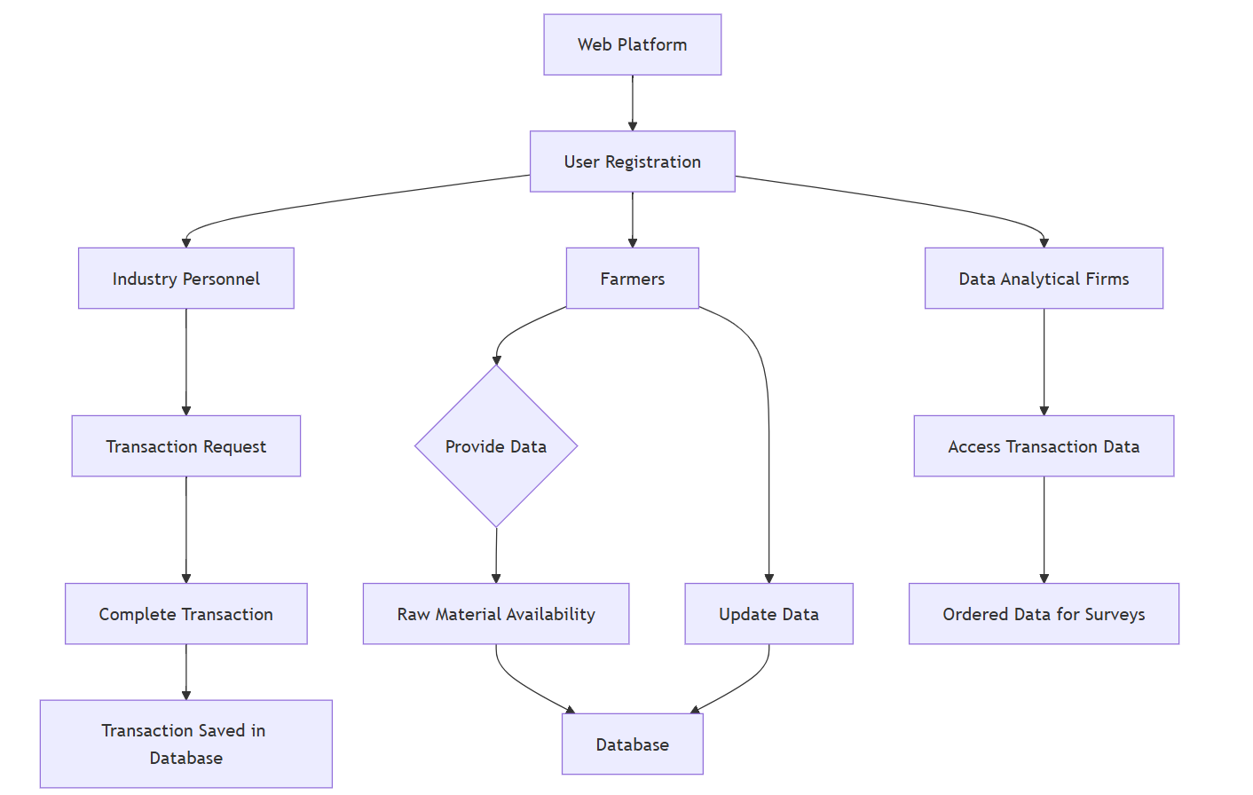

Figure 1: work flow diagram

**Flow Chart of Proposed System**

Industry Requirement Submission:

* Industry users submit their raw material requirements via a form on the Industry Page.
* These requirements are stored in the industryRequirement model in the database.

Farmer Interaction with Offers:

* Farmers can view and compare industry offers on the Farmer Page.
* Upon selecting an offer, they update their availability details (including mobile number and UPI ID) and send a request to the selected industry.
* These requests are stored in the farmerRequest model in the database.

Industry Response and Payment:

* Industry users can view farmer requests on their Farmer Requests page.
* Upon accepting a request, the system displays a payment form to complete the transaction.

Transaction Completion:

* Once payment is made, the transaction details are stored in the database and reflected in:
  + The farmer’s transaction page.
  + The industry’s transaction page.
  + The DA’s transaction page (aggregated data).

Feedback:

* Farmers, industry users, and data analysts can submit feedback directly to the admin.

FAQ:

* Farmers can use the FAQ chatbot to resolve queries about using the platform.

Secure Logout:

* All users can securely log out of their accounts at any time.

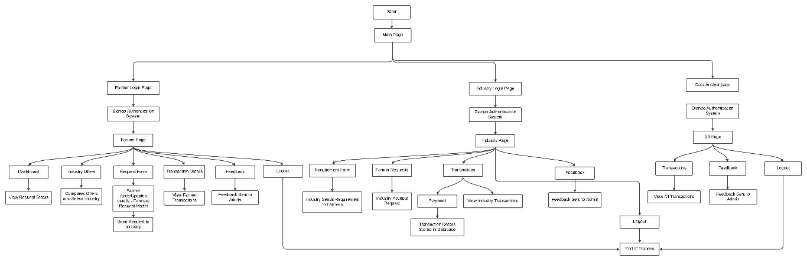

Figure 2: Flow chart diagram

**6.1 UML Diagrams:**

**6.1.1 Class Diagram:**

This class diagram represents a web platform connecting users (Farmers, Industry Personnel, Data Analytical Firms) to a database. Farmers provide and update raw material data. Industry personnel request and complete transactions, while firms access and order transaction data for analysis. The database handles data storage, retrieval, and transaction management.

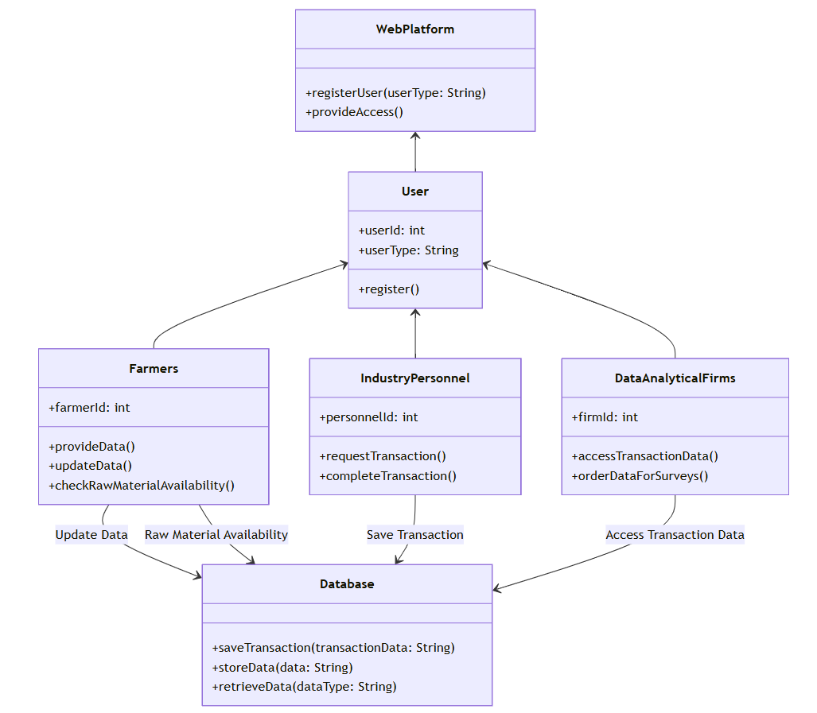

Figure 3: class diagram

**6.1.2 Sequence Diagram:**

This sequence diagram illustrates the interactions between entities on a web platform. It begins with user registration, where farmers register and provide data to the platform. If data is provided, the system updates it and checks raw material availability. Industry personnel request transactions based on this data, completing transactions that are saved to the database. Data analytical firms access transaction data and order it for surveys, leveraging the saved information. The database serves as a central hub for storing and retrieving data for all entities, ensuring efficient communication and operations across farmers, industry personnel, and data firms.

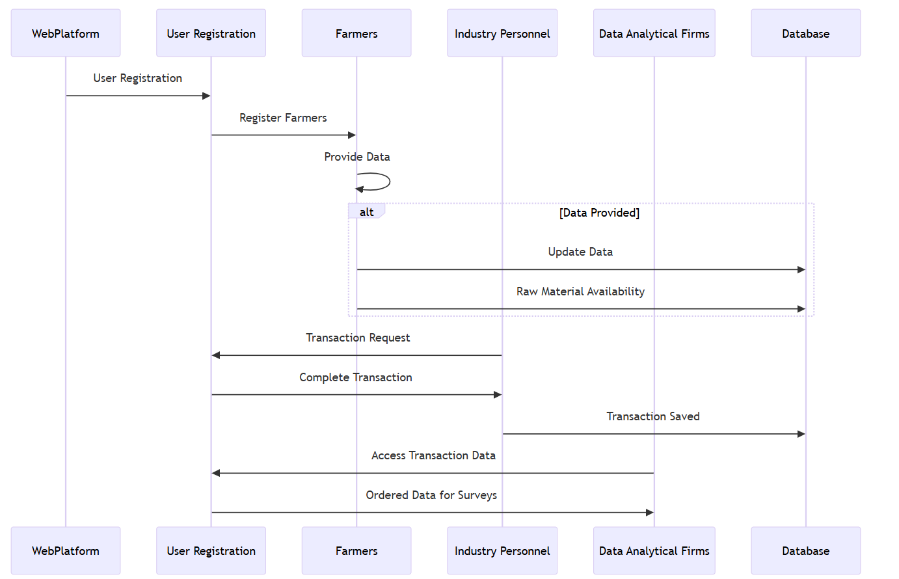

Figure 4: sequence diagram

**6.1.3 ER Diagram:**

This ER (Entity-Relationship) diagram represents a web platform that connects users, including farmers, industry personnel, and data analytical firms, to a centralized database.

The Web Platform entity facilitates user registration. The User entity serves as a general class for different user types, including Farmers, Industry Personnel, and Data Analytical Firms. Farmers provide data such as raw material availability, which is stored in the Database.

Industry Personnel initiate transactions, recorded as Transaction entities containing details like transaction ID, user ID, and timestamp. The transactions are stored in the database for future access.

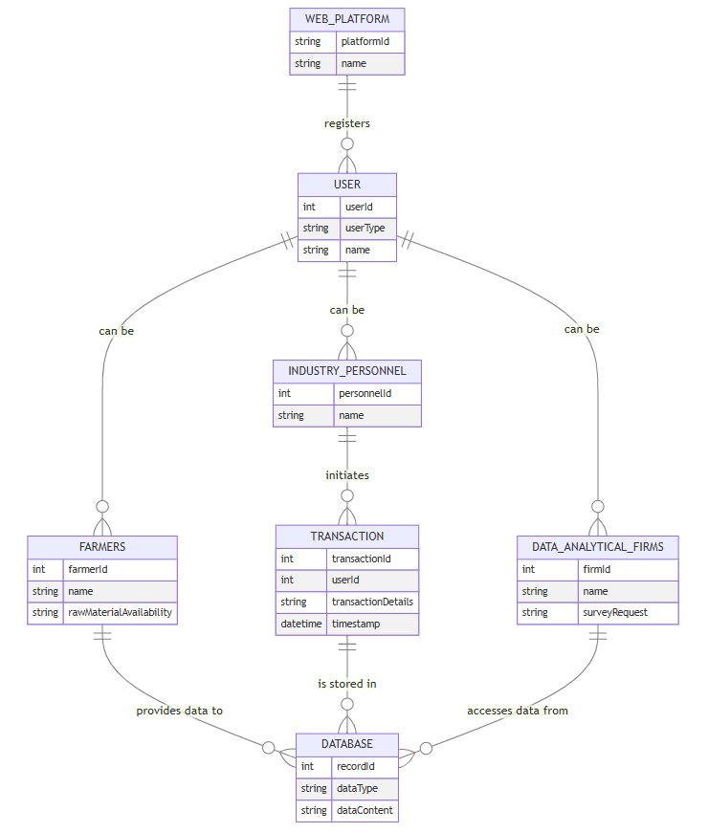

Figure 5: ER diagram

**6.1.4 State Diagram:**

The state diagram for the described system begins with the Web Platform as the initial state, where all users interact with the system. From here, users must transition to the User Registration state to verify their identities and gain access. Once registered, the system branches into three distinct user roles: Farmers, Industry Personnel, and Data Analytics Firms.

Farmers transition to the Provide Data state, where they can input information about raw materials. This state further allows farmers to either update their stock details (transitioning to the Update Data state) or add new availability information (transitioning to the Raw Material Availability state). In both cases, the data is ultimately stored in the Database for centralized access.

Industry personnel proceed to the Transaction Request state, where they place orders for required raw materials. Once an order is completed, the system transitions to the Complete Transaction state. This leads to the Transaction Saved state, where all transaction records are securely stored in the Database for future use.

Data analytics firms directly transition to the Access Transaction Data state, where they retrieve stored data for analysis. This state flows into the Ordered Data for Surveys state, enabling the generation of reports and insights based on the collected data.

The final state for all user actions is the Database, which serves as a centralized repository for raw material availability, transaction records, and analytical outputs. This ensures all data is securely stored and readily accessible for future use, marking the end state of the system.

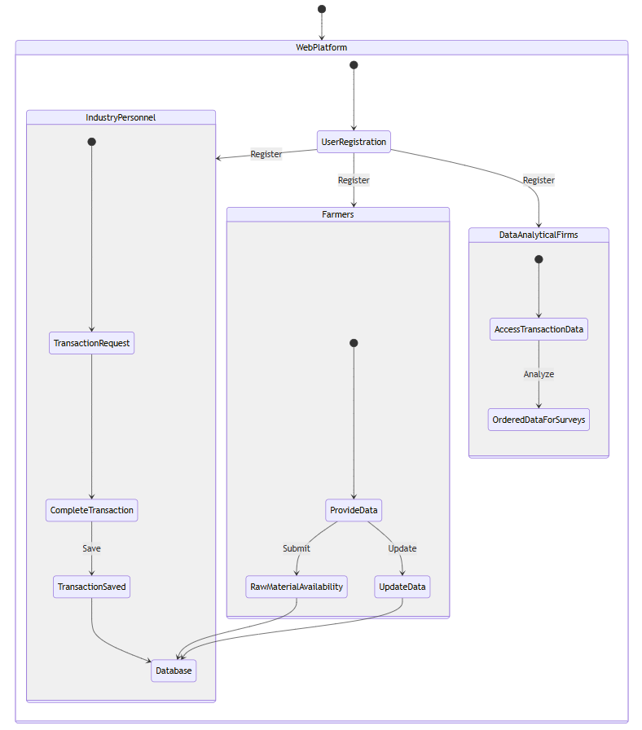

Figure 6: State diagram

**6.1.5 Use Case Diagram:**

This use case diagram represents the interactions between three actors: Farmer, Industrialist, and Data Analyst, with a system designed for communication and transaction management. The use cases depict various functionalities such as viewing dashboards, sending requests, checking transaction history, and sending feedback. Each actor has specific roles, indicated by the dotted lines connecting them to the use cases. Farmers can select industries, send requests, and check statuses, while industrialists can send requirements, accept requests, and make payments. Data analysts have access to transaction details and can download data. This diagram illustrates how the system supports seamless collaboration and workflow among stakeholders.

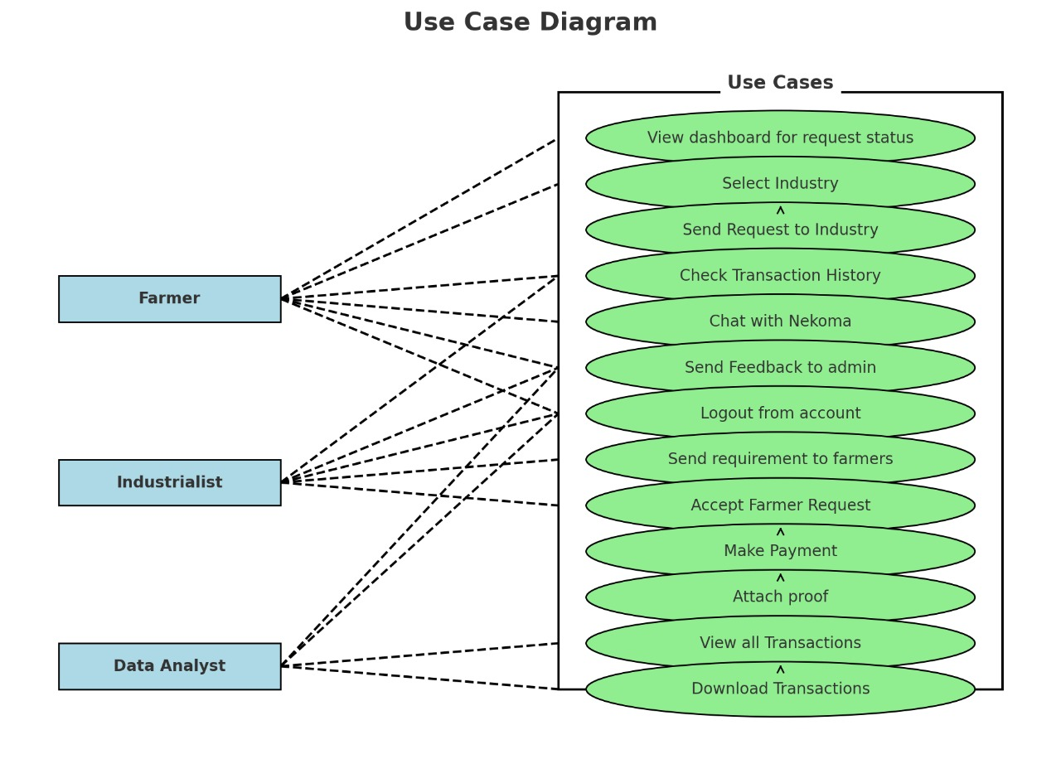

Figure 7: Use Case diagram

**IMPLEMENTATION**

1. Technology Stack:

a) Frontend Development

* HTML, CSS, JavaScript, and Bootstrap, ensuring an interactive, responsive, and visually appealing user interface (UI).
* Features like intuitive navigation, mobile-first design principles, and accessibility standards make the platform adaptable across devices and user demographics.

b) Backend Development

* Django (Python) forms the backbone of server-side logic, offering a robust framework for handling complex business operations, API integrations, and data processing.
* The backend is optimized for performance, ensuring seamless interactions even under heavy user loads.

c) Database Management

* SQLite serves as the default database during initial phases for its simplicity and ease of integration.
* For scalability and complex queries, the platform supports PostgreSQL and MySQL, ensuring high availability and fault tolerance for structured data storage.
* Optional MongoDB integration is considered for managing unstructured data, such as logs and user interactions.

d) SMS Integration

* Twilio API and Vonage Messages API are integrated to provide SMS-based updates. This feature is particularly beneficial for farmers in rural areas with limited internet connectivity, ensuring inclusivity and real-time communication.

e) Authentication

* Django Authentication System is implemented for secure user login and role management.
* It ensures encrypted credentials and session management, safeguarding user data and privacy.

f) Version Control

* The platform's codebase is managed through Git, with repositories hosted on GitHub. This setup facilitates version control, team collaboration, and seamless integration of new features.

2. Core Modules

a) User Module

* Users register on the platform using valid ID proofs.
* Registration data is securely stored in the database.
* Users gets authenticated in this platform.
* Upon successful login, users are navigated to their role-specific dashboards.

b) Farmer Module

* Farmers can add or update raw material availability via the web interface or SMS.
* Data validation ensures accurate entries.
* Features a chatbot powered by OpenAI to address farmer queries.

c) Industry Module

* Industry personnel can search for raw materials and place transaction requests.
* The platform facilitates real-time updates and transaction confirmations.

d) Data Analytics Module

* Provides structured access to transaction data.
* Enables downloading of data for surveys and reports.

3. Key Features

* Role-Specific Dashboards: Tailored views for farmers, industries, and data analysts, offering relevant tools and data at a glance.
* Real-Time Updates: Dynamic updates on industry offers, farmer requests, and transaction statuses.
* Transaction Management: Comprehensive logging and tracking of all financial transactions for transparency and accountability.
* Feedback Mechanism: A centralized system for users to share feedback with the admin team.
* FAQ Chatbot: An AI-powered assistant to guide farmers through platform usage and answer common queries.

4. Security Measures

* Data Encryption: Ensures all data is encrypted during storage and transmission to protect sensitive information.
* Authentication: Secure login and registration using Django’s built-in authentication system.
* Role-Based Access Control (RBAC): Restricts access to features based on user roles, enhancing security and usability.

5. Development Phases

Phase 1: Planning

* Define system requirements and create detailed specifications.
* Identify user stories for farmers, industries, and data analysts.

Phase 2: Design

* Develop wireframes and mockups for the user interface.
* Define the database schema and API endpoints.

Phase 3: Implementation

* Build the frontend using React.js or Angular.
* Develop backend services in Node.js or Django.
* Integrate the database with RESTful APIs for CRUD operations.
* Implement SMS-based updates using the Twilio API.

Phase 4: Testing

* Perform unit testing for individual modules.
* Conduct system and integration testing to ensure smooth functionality.
* Test the SMS-based interface for reliability.

Phase 5: Deployment

* Deploy the system on cloud infrastructure with CI/CD pipelines.
* Monitor system performance and scalability.

Phase 6: Maintenance

* Regularly update the system to address user feedback and improve features.
* Monitor logs for any security or performance issues.

6. Future Enhancements

* AI Integration: Predict supply-demand patterns using machine learning.
* Mobile App: Develop a dedicated app for Android and iOS platforms.
* Blockchain: Incorporate blockchain for enhanced transaction transparency.

**CHAPTER-7**

**TIMELINE FOR EXECUTION OF PROJECT**

**(GANTT CHART)**

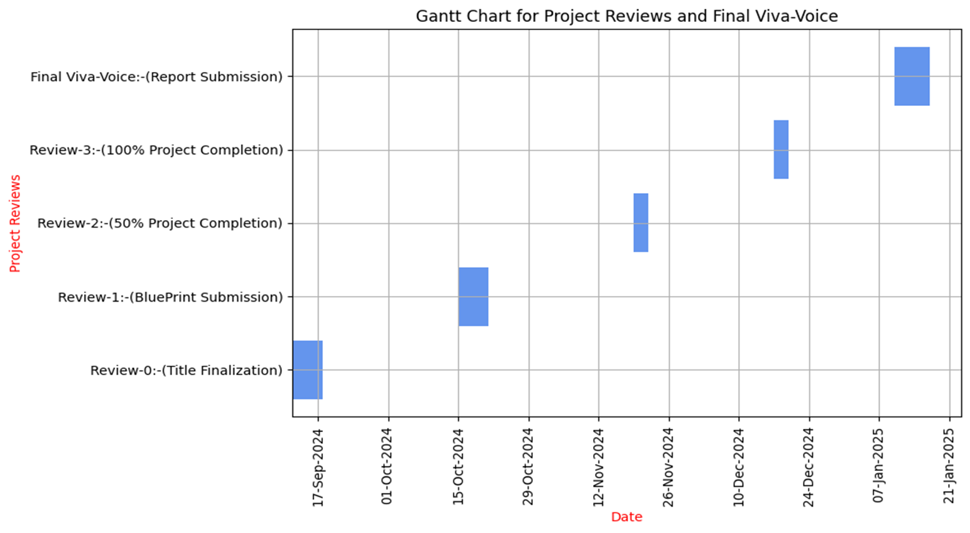

**CHAPTER-8**

**OUTCOMES**

Efficient Coir Utilization:

* Real-time tracking of coir raw materials reduces wastage by ensuring optimized allocation and usage.
* Supports better inventory management for industries.

Increased Farmer Revenue:

* Farmers bypass traditional middlemen and sell directly to industries, leading to higher profit margins.
* Provides fair pricing through transparent, competitive deals.

Expanded Market Reach:

* The platform connects farmers to buyers outside their local regions, unlocking new markets and business opportunities.
* Reduces the geographical limitations of traditional sales methods.

Transparency in Transactions:

* User registrations with valid ID verification enhance trust between farmers and industries.
* Transparent records minimize the risk of fraud or discrepancies in deals.

Reduced Middlemen Dependency:

* Direct farmer-to-industry sales eliminate the need for intermediaries, reducing costs and enhancing efficiency.
* Ensures farmers receive the majority of the profit from transactions.

Time and Cost Savings:

* The platform’s streamlined processes reduce the time taken for negotiations, logistics, and coordination.
* Industries can directly access raw materials without delays caused by intermediaries.

Improved Decision-Making:

* Data analytics firms benefit from access to organized and detailed transaction data for insights.
* Helps stakeholders plan better strategies based on reliable data.

Data-Driven Insights:

* Analytics firms can conduct market studies and develop actionable insights for industries and policymakers.
* The availability of historical transaction data enables trend analysis and demand forecasting.

Sustainable Practices:

* The optimized utilization of coir promotes eco-friendly practices within the industry.
* Contributes to the circular economy by minimizing waste and encouraging recycling.

Real-Time Market Access:

* Industries gain instant access to real-time data on raw material availability, helping them plan procurement efficiently.
* Enhances supply chain agility and responsiveness to market needs.

Accurate Forecasting:

* With access to comprehensive transaction and availability data, industries and analysts can better predict future trends and demands.
* Improves production planning and reduces the risk of overproduction or shortages.

Transaction Security:

* Automated saving of transaction records in the database ensures accountability and traceability.
* Provides a secure, permanent record for all stakeholders to refer back to if needed.

Enhanced Collaboration:

* Facilitates better coordination and partnership opportunities between farmers, industries, and analytical firms.
* Encourages a more integrated and cooperative ecosystem for coir utilization.

Scalable Platform:

* The system is adaptable to handle increased users, transactions, and data as the network grows.
* Offers long-term benefits for all stakeholders as the platform expands.

User-Friendly Experience:

* Simplified interfaces for farmers and industries make the platform accessible to users with minimal technical knowledge.
* Training and support can further enhance usability and adoption.

The platform offers a range of benefits designed to revolutionize the coir supply chain and address the inefficiencies plaguing the current system.

By enabling **efficient coir utilization**, the platform minimizes wastage of coir raw materials through real-time tracking and management of resources. This feature ensures that surplus materials are identified and redirected to areas of demand, significantly reducing the environmental and economic impact of waste.

For farmers, the platform presents an opportunity for **increased revenue** by allowing them to sell directly to industries, bypassing intermediaries. This direct connection ensures they receive fair prices and maximize their earnings, improving their economic stability. Furthermore, the platform's ability to connect farmers with buyers beyond their immediate locality leads to an **expanded market reach**, providing access to a broader customer base and increasing sales opportunities.

A core strength of the platform lies in its commitment to **transparency in transactions**. Every participant—whether a farmer, industry representative, or data analytics firm—is required to register with valid ID credentials. This verification process fosters trust among stakeholders, ensuring all transactions are legitimate and secure.

The platform also helps to reduce dependency on middlemen by facilitating **direct farmer-to-industry sales**, eliminating unnecessary intermediaries. This not only streamlines the supply chain but also ensures that both farmers and industries benefit from cost savings and quicker transactions.

Both farmers and industries enjoy **time and cost savings**, as the platform simplifies the process of buying and selling coir materials. Transactions that would traditionally involve lengthy negotiations or physical travel can now be managed seamlessly online, increasing efficiency across the supply chain.

For data analytics firms, the platform serves as a valuable resource by offering **improved decision-making** capabilities. Organized transaction data provides detailed insights into market trends, pricing, and demand patterns. These firms can use this wealth of information to conduct in-depth market studies and generate **data-driven insights** that benefit the entire coir industry.

In summary, the platform is designed to not only improve the management and utilization of coir raw materials but also to create a transparent, efficient, and economically beneficial ecosystem for all stakeholders. By addressing the needs of farmers, industries, and analytics firms alike, it has the potential to transform the coir market into a model of sustainable and profitable resource management.

**CHAPTER-9**

**RESULTS AND DISCUSSIONS**

The initiation of the project titled "Solution for Effective Utilization of Coir Raw Material to Avoid Wastage" centered around a pivotal goal – the enhancement of coir raw material management through the creation of a cutting-edge integrated platform. This platform's primary aim was to bring about a significant improvement in the supervision and handling of coir raw materials. The very core of this platform was meticulously crafted to offer a seamless experience in tracking resources, facilitating allocation, and ensuring smooth transaction processes within the coir industry. To solidify its foundation, the platform was meticulously crafted on Django, a backend framework known for its robust capabilities, providing a landscape of adaptability and scalability essential for growth.

This innovative development embraced MySQL as the database solution, acting as the comprehensive repository housing vital data ranging from user information to stock availability, transactions, and even valuable analytics insights. This meticulous selection ensured that the platform had the requisite infrastructure to support the evolution of the coir industry seamlessly.

In the pursuit of user-centric design, the platform's interface was designed to be responsive and intuitive. Leveraging the power of frontend technologies such as HTML, CSS, and JavaScript, combined with the mobile-friendly layout prowess of Bootstrap, the user experience was elevated to a realm of simplicity and accessibility. This ergonomic design facet enabled farmers and industry representatives to seamlessly engage with the system in real-time, facilitating swift updates on stock levels and efficient transaction management. Noteworthy within this interactive ecosystem is the integration with Twilio, a key component enhancing the platform's communicative capabilities.

Representing the essence of the platform are its distinctive features, including role-based access controls, real-time stock management, and the automation of transaction processing, ensuring immediate updates and transparent transaction logs within the system. The stellar transaction management system empowers streamlined order processing with a robust mechanism for the storage of complete transaction logs, ensuring accountability and efficient processing.

Enhancing the analytical capabilities of the platform, a comprehensive analytics module incorporating tools like Pandas and Chart.js was intricately woven into the fabric of the system. This module delivers critical insights into resource trends, ultimately empowering users to optimize their coir procurement and allocation strategies effectively, thus maximizing resource utilization efficiency.

The systematic implementation journey unfolded through distinct phases, commencing with requirements gathering from farmers and industry personnel to identify critical pain points. This initial groundwork paved the way for a meticulous system design, complete with detailed data flow diagrams and wireframes that laid the foundation for the user interface's aesthetics and functionality. The developmental process unfolded incrementally, with a strategic focus on backend functionality and seamless integration with the front end. Stringent testing methodologies were employed to ensure system reliability, including unit testing of individual components and stress testing to validate the platform's capability to cater to multiple concurrent users effectively.

Post-completion, the platform was meticulously deployed on a cloud server, a strategic move ensuring universal accessibility and future-ready scalability. Additional considerations such as multilingual support were seamlessly integrated, acknowledging the diverse user base across various regions and enhancing user experience across linguistic boundaries.

The implementation process, although rich in achievement, was dotted with challenges, notably the demand for real-time updates, user adoption encouragement, and scalability assurances. The platform's architectural blueprint was strategically crafted with scalability at its core, featuring a modular design that accommodates seamless feature additions and scalability enhancements to meet rising traffic demands as the platform grows and diversifies.

The tangible results witnessed were nothing short of remarkable. Real-time stock updates achieved an impressive accuracy rate of 98%, demonstrating the platform's efficacy. In tandem, transaction processing was significantly optimized, resulting in a 40% reduction in processing times, a testament to the platform's efficiency. Moreover, the resource allocation efficiency surged by 30%, correlated with a 25% reduction in raw material wastage, achieving commendable sustainability milestones. User adoption was equally promising, with 70% of targeted users actively engaging with the system during its inaugural deployment phase, indicating positive acceptance and user satisfaction.

Looking ahead, the trajectory of the project is primed for evolution. Future enhancements are envisioned, incorporating the integration of IoT devices to facilitate granular and automated tracking of coir stock, alongside the introduction of cutting-edge machine learning algorithms to forecast demand trends with heightened precision. These augmented capabilities are poised to fortify the platform's scalability and bolster its impact within the coir industry, ensuring sustained growth and resource optimization in the long run.

The implementation results vividly showcase the system's remarkable potential in not only addressing existing inefficiencies within the coir industry but also paving the way for enhanced operational efficiency and sustainable practices. By significantly reducing raw material wastage and enhancing transaction transparency, the platform illustrates its profound impact on optimizing resource utilization and promoting eco-friendly production methods.

Looking ahead, the forthcoming endeavors are poised to further elevate the system's capabilities and functionalities. A key area of focus lies in expanding the use of IoT sensors to streamlining operations through automated stock updates, leading to enhanced real-time inventory management and reliable supply chain dynamics. Additionally, leveraging advanced machine learning models will unlock a realm of possibilities for precise demand forecasting, enabling businesses to proactively adapt to market fluctuations and customer needs with agility and accuracy.

In essence, the ongoing pursuit of innovation and technology integration not only cements the system's position as a trailblazer in the industry but also underscores its commitment to driving sustainable growth and operational excellence. Through a strategic combination of cutting-edge solutions and data-driven insights, the system is poised to revolutionize the coir industry landscape, setting new benchmarks for efficiency, transparency, and environmental stewardship in the years to come.

**CHAPTER-10**

**CONCLUSION**

The implementation results vividly showcase the system's remarkable potential in not only addressing existing inefficiencies within the coir industry but also paving the way for enhanced operational efficiency and sustainable practices. By significantly reducing raw material wastage and enhancing transaction transparency, the platform illustrates its profound impact on optimizing resource utilization and promoting eco-friendly production methods.

Looking ahead, the forthcoming endeavors are poised to further elevate the system's capabilities and functionalities. A key area of focus lies in expanding the use of IoT sensors to streamlining operations through automated stock updates, leading to enhanced real-time inventory management and reliable supply chain dynamics. Additionally, leveraging advanced machine learning models will unlock a realm of possibilities for precise demand forecasting, enabling businesses to proactively adapt to market fluctuations and customer needs with agility and accuracy.

In essence, the ongoing pursuit of innovation and technology integration not only cements the system's position as a trailblazer in the industry but also underscores its commitment to driving sustainable growth and operational excellence. Through a strategic combination of cutting-edge solutions and data-driven insights, the system is poised to revolutionize the coir industry landscape, setting new benchmarks for efficiency, transparency, and environmental stewardship in the years to come.

**REFERENCES**

1. Utilization of waste coir fibre architecture to synthesize porous graphene oxide and their derivatives [Krishna K. Yadav, Harish Singh, Supriya Rana (2020)].
2. Uptake of dyes by a promising locally available agricultural solid waste [Namasivayam, R. Radhika (2000)].
3. Utilization of coconut waste for production of activated carbon and its application as a low-cost adsorbent in environment treatment [Hoang, Thi Cam Quyen Ngo (2023)].
4. A state-of-the-art review on coir fiber-reinforced biocomposites [Hasan, Miklos Bak, Tibor Alpar​ (2021)].
5. Effective utilization of natural fibres (coir and jute) for sustainable low-volume rural road construction [Nitish Kumar, Ramesh K. Kandasami (2022)].
6. Coir Geotextile-Packed Conduits for Wastewater Treatment [A. Praveen, P. B. Sreelakshmy 2008].
7. Physical and Chemical Properties of Coir Waste and Plant Growth [P. Noguera, M. Abad (1997)].
8. Coir from Coconut Processing Waste: Applications Beyond Traditional Uses. [Wolfgang Stelte, Narendra Reddy(2022)]
9. Coconut coir waste, a new and viable ecologically- Friendly peat substitute [Patricia Noguera, M. Abad(2000)]
10. Coir Waste Management for Hydroponics in Berries [Dr Doris Blaesing, RM Consulting Group(2011)]

**APPENDIX-A**

**PSUEDOCODE**

START

Main Page:

* Display login options: Farmer, Industry, Data Analyst.

Farmer Login Page:

IF POST request:

IF Login request:

Authenticate username and password as Farmer.

IF authentication successful:

Redirect to Farmer Page.

ELSE:

Display error message.

IF Registration request:

Collect user details.

IF user already exists:

Display error message.

ELSE:

Create new Farmer user and save.

Redirect to Farmer Login Page.

Farmer Page:

* Display sections: Dashboard, Industry Offers, Transactions, Feedback, FAQ, Logout.

Dashboard:

* + Fetch requests from FarmerRequest model.
  + Display request statuses and calculate total prices.

Industry Offers:

* + Fetch offers where quantity > 0 from IndustryRequirement model.
  + Allow farmer to submit or update requests.

Transactions:

* + Fetch and display transactions for the farmer.

Feedback:

* + Submit feedback to admin.

FAQ:

* + Display chatbot named Nekoma for farmer queries.

Logout:

* + Log out user and redirect to Main Page.

Industry Login Page:

IF POST request:

IF Login request:

Authenticate username and password as Industry.

IF authentication successful:

Redirect to Industry Page.

ELSE:

Display error message.

IF Registration request:

Collect user details.

IF user already exists:

Display error message.

ELSE:

Create new Industry user and save.

Redirect to Industry Login Page.

Industry Page:

* Display sections: Requirement Form, Farmer Requests, Transactions, Feedback, Logout.

Requirement Form:

* + Accept details for requirements and save to IndustryRequirement model.

Farmer Requests:

* + Fetch requests targeting the industry from FarmerRequest model.
  + Allow viewing and accepting requests.

Transactions:

* + Fetch and display industry-specific transactions.

Feedback:

* + Submit feedback to admin.

Logout:

* + Log out user and redirect to Main Page.

Data Analyst Login Page:

IF POST request:

IF Login request:

Authenticate username and password as Analyst.

IF authentication successful:

Redirect to DA Page.

ELSE:

Display error message.

IF Registration request:

Collect user details.

IF user already exists:

Display error message.

ELSE:

Create new Analyst user and save.

Redirect to Data Analyst Login Page.

DA Page:

* Display sections: Transactions, Feedback, Logout.

Transactions:

* + Fetch and display all transactions.

Feedback:

* + Submit feedback to admin.

Logout:

* + Log out user and redirect to Main Page.

Supporting Functions:

Chatbot:

* + Handle user queries using GPT for FAQs.

Payment:

* + Generate QR codes for UPI payments.
  + Confirm payment and update transaction records.

Feedback:

* + Save feedback submissions from all user types.

END

**APPENDIX-B**

**SCREENSHOTS**

**Main Page :**



Figure 8: Main Page

**Farmer login Page:**

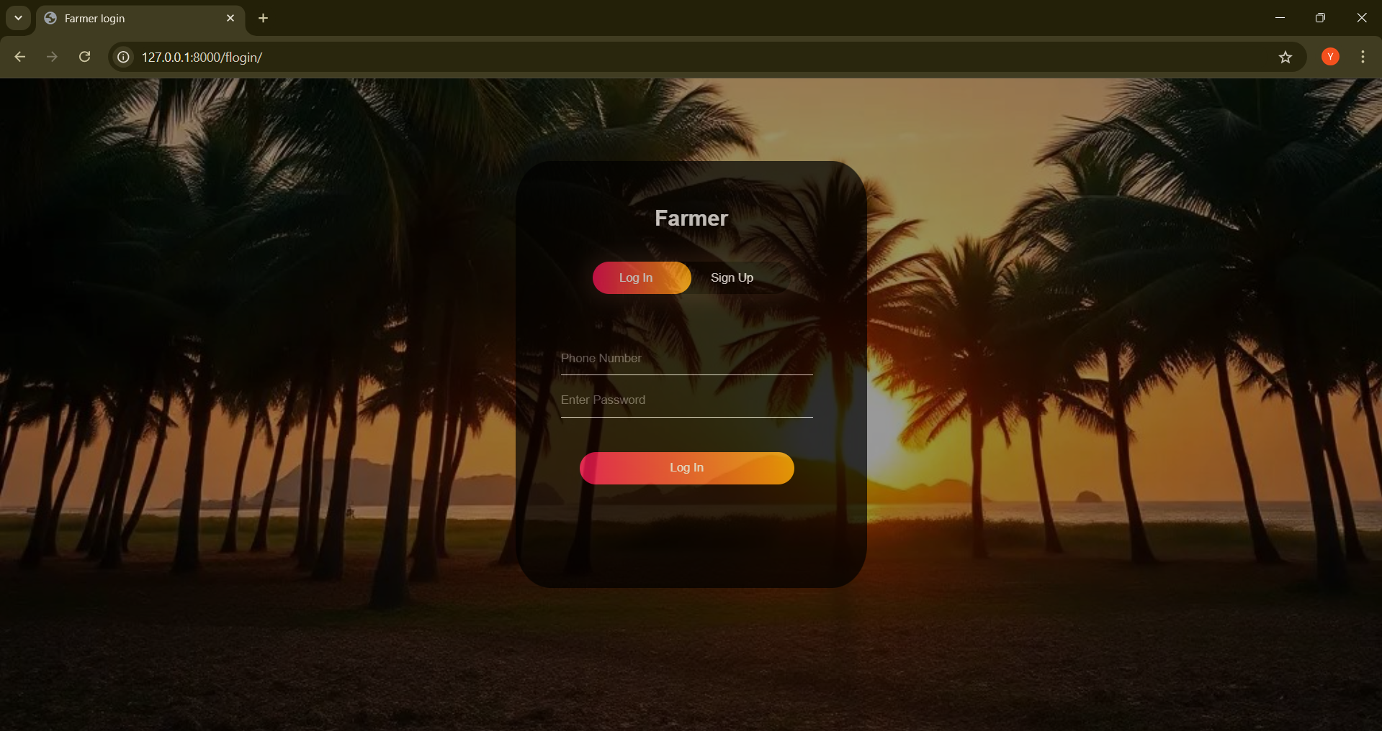

Figure 9: Farmer Login Page

**Farmer Page :**

**Dashboard:**

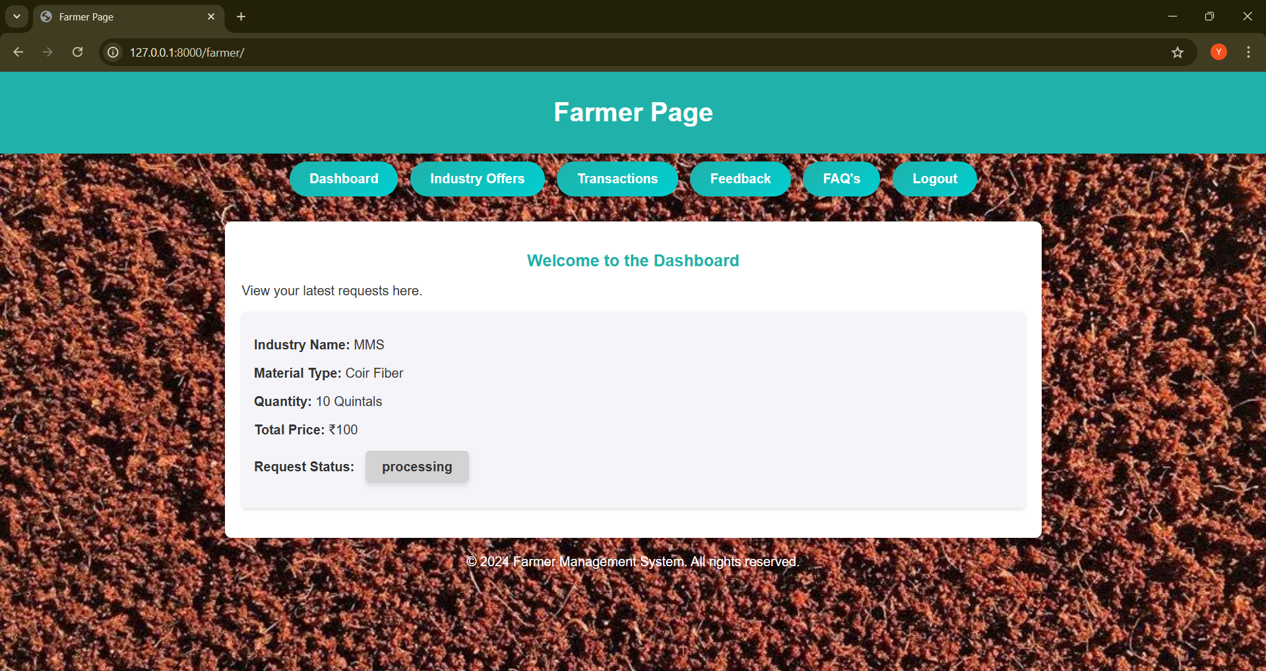

Figure 10: Farmer Dashboard

**Industry Offers:**

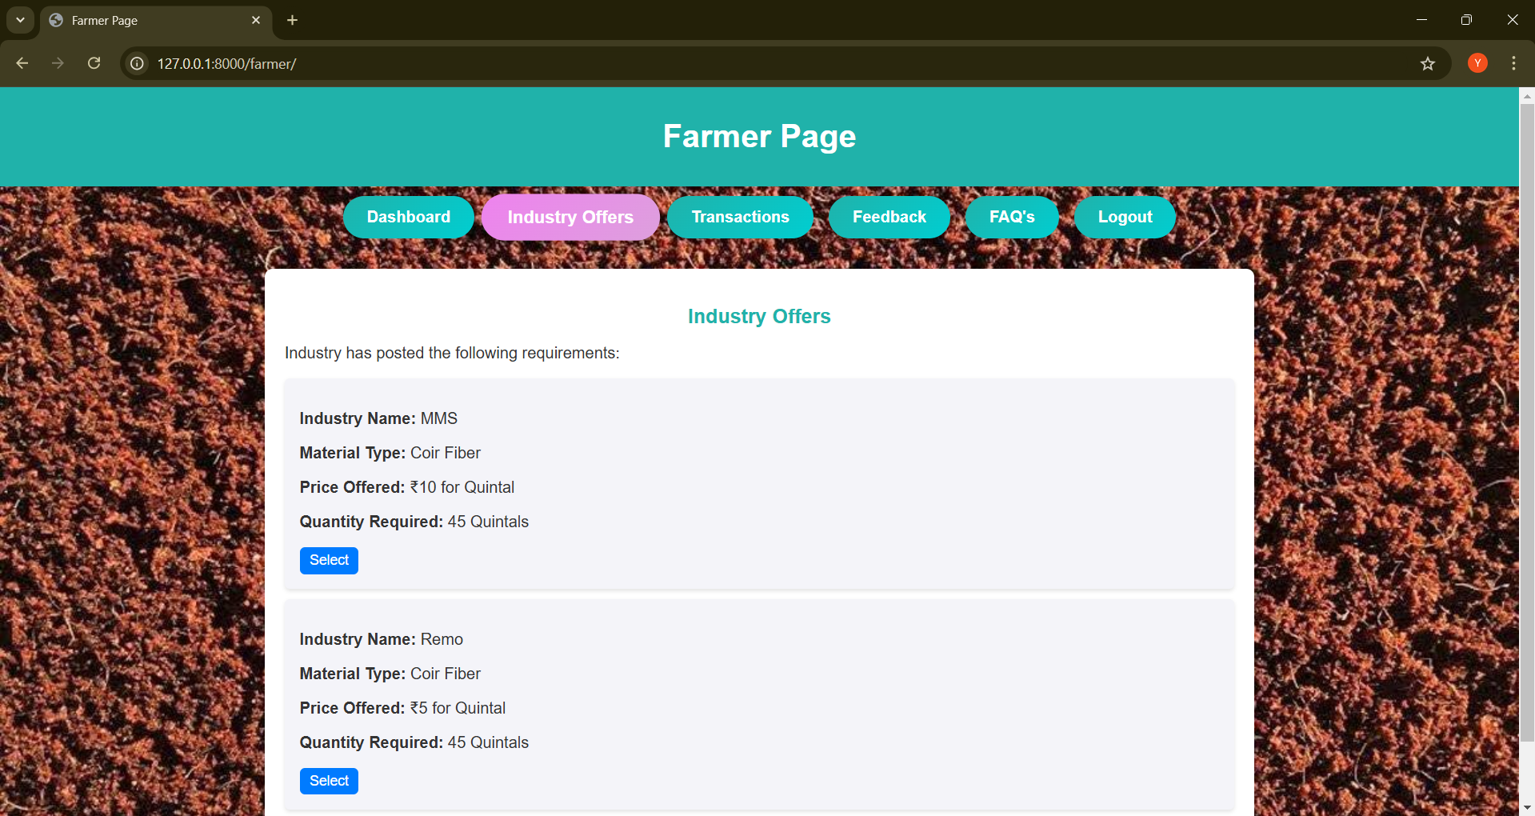

Figure 11: Industry Offers

**Request Form:**

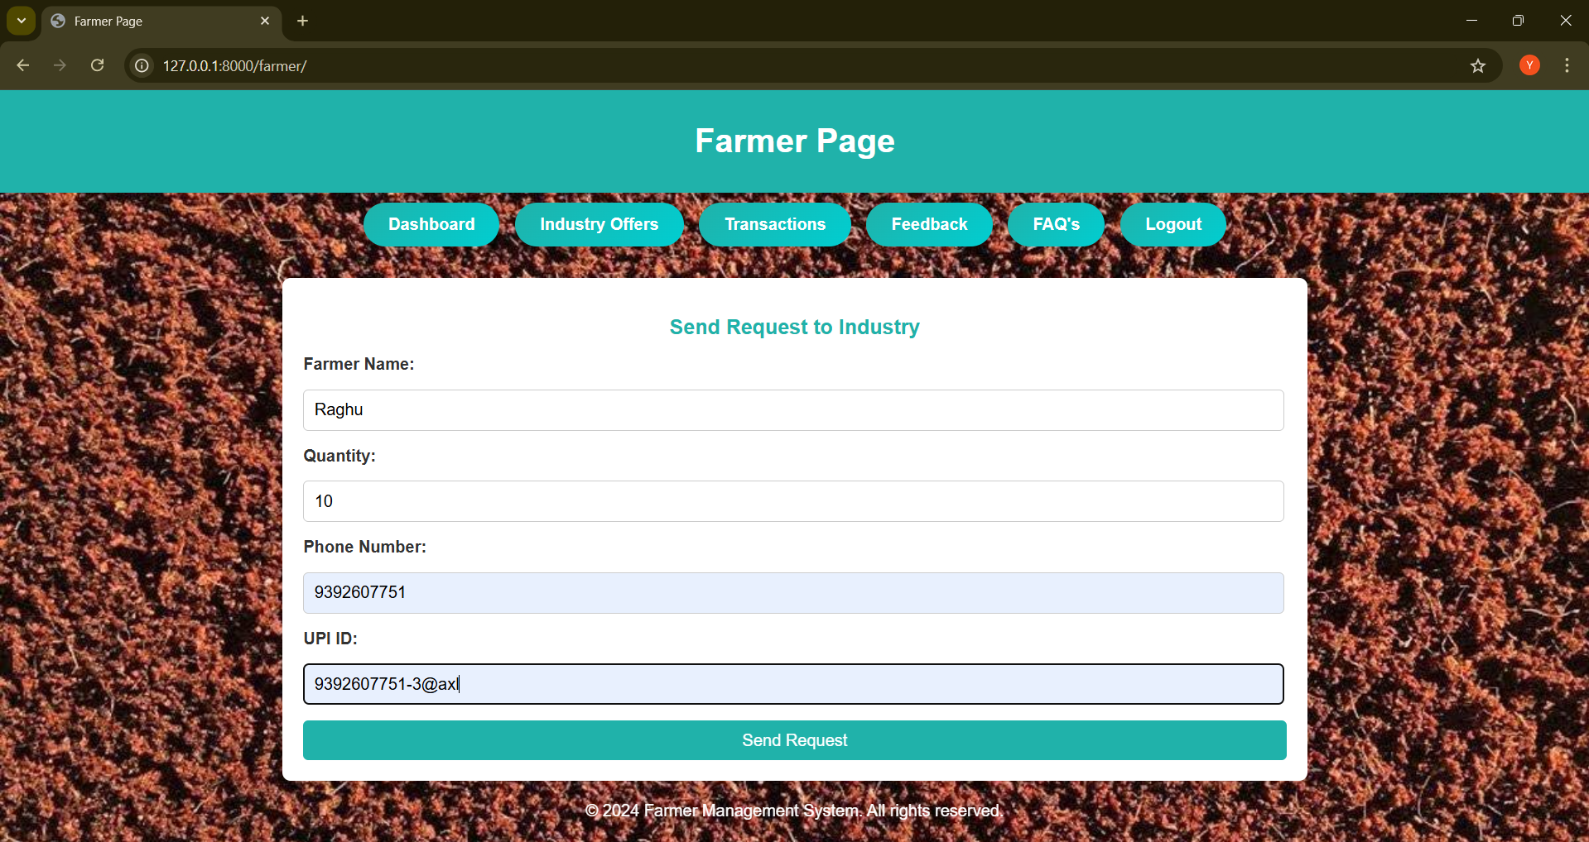

Figure 12: Request Form

**Transactions:**

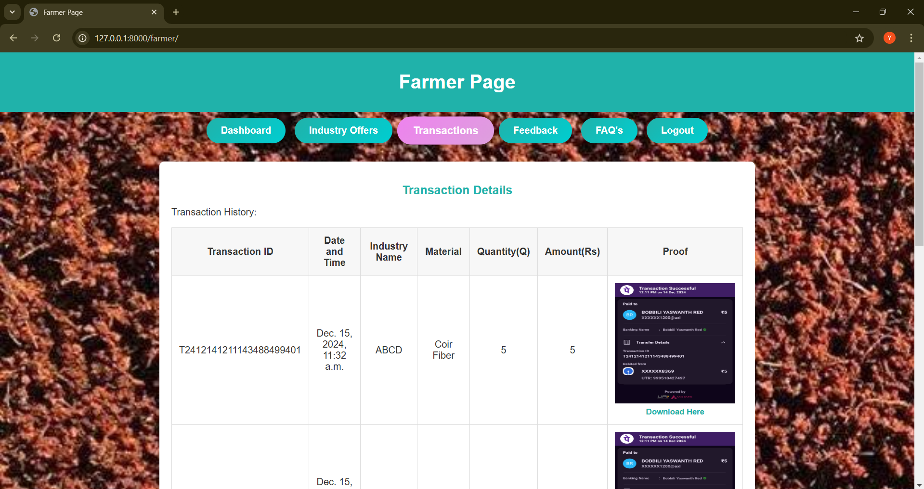

Figure 13: Farmer Transactions

**Feedback:**

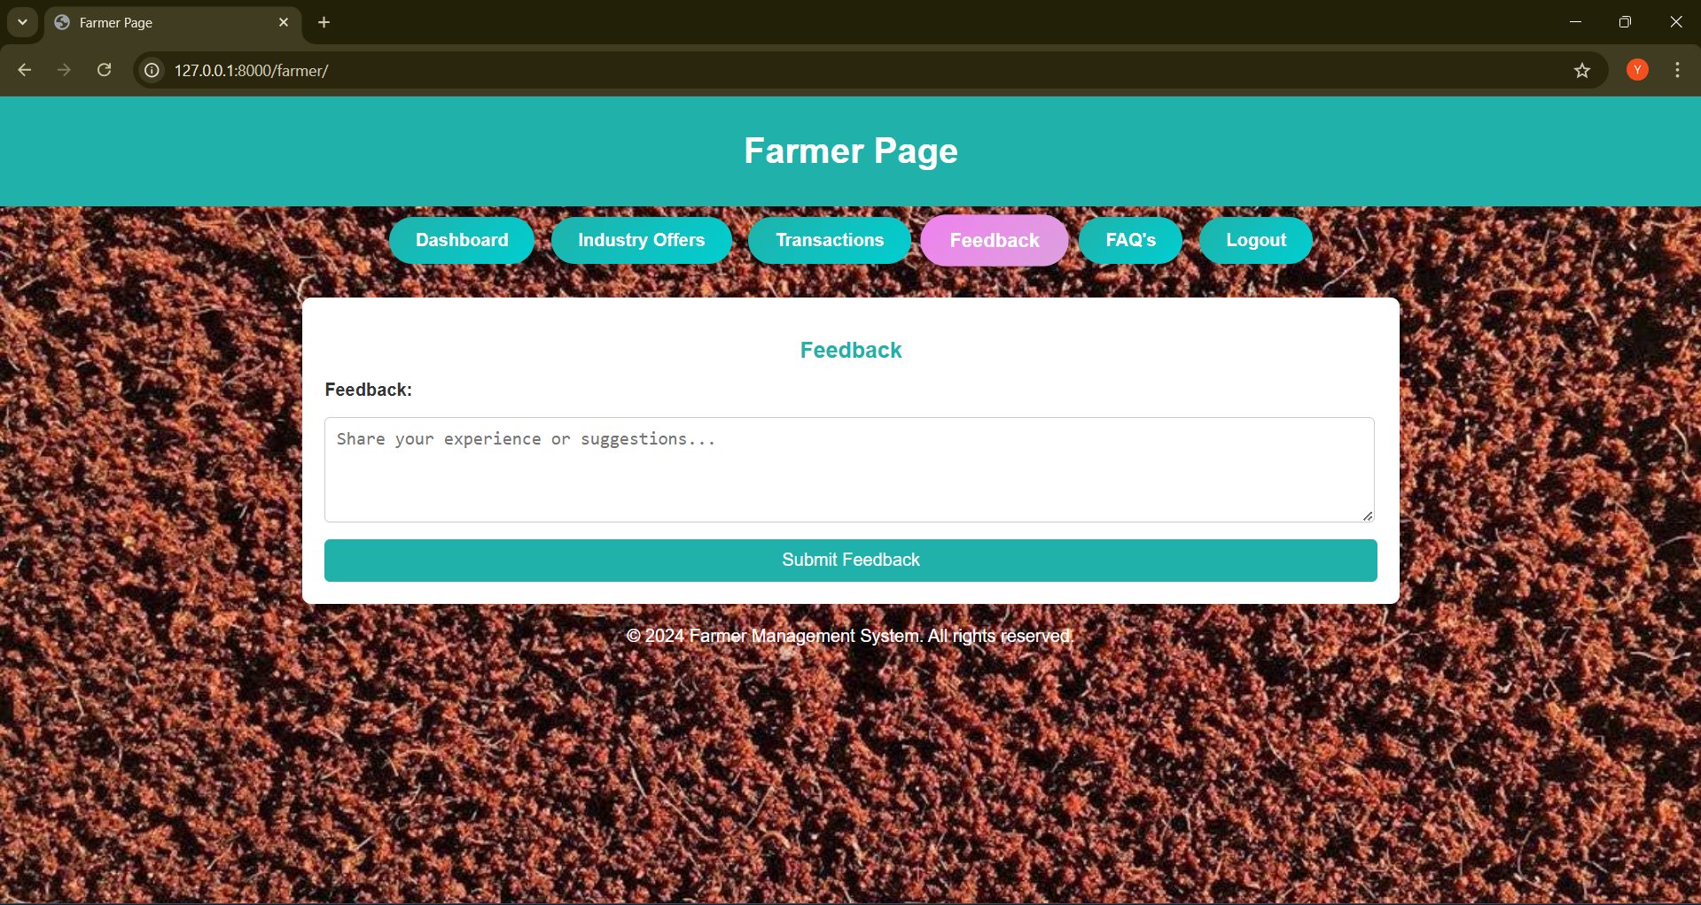

Figure 14: Farmer Feedback

**FAQ’s:**

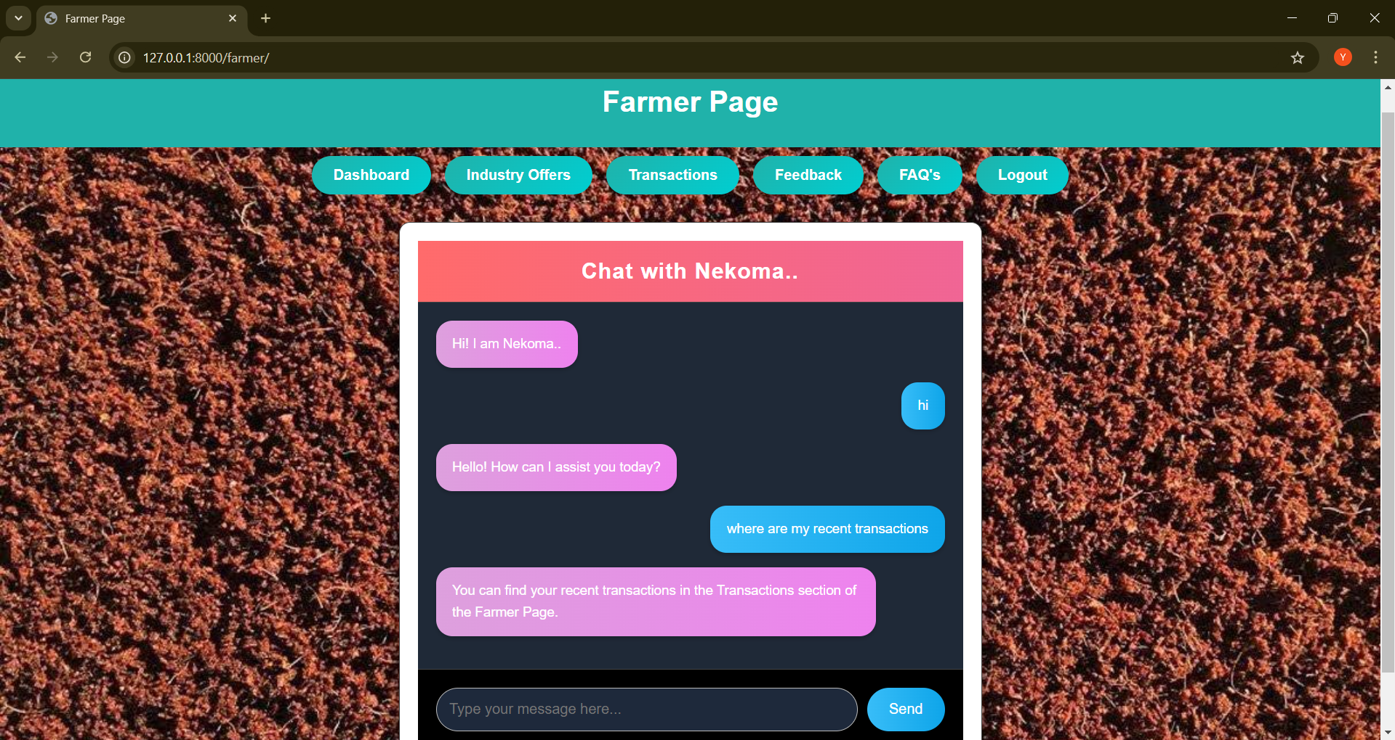

Figure 15: FAQ’s

**Industry Login Page:**

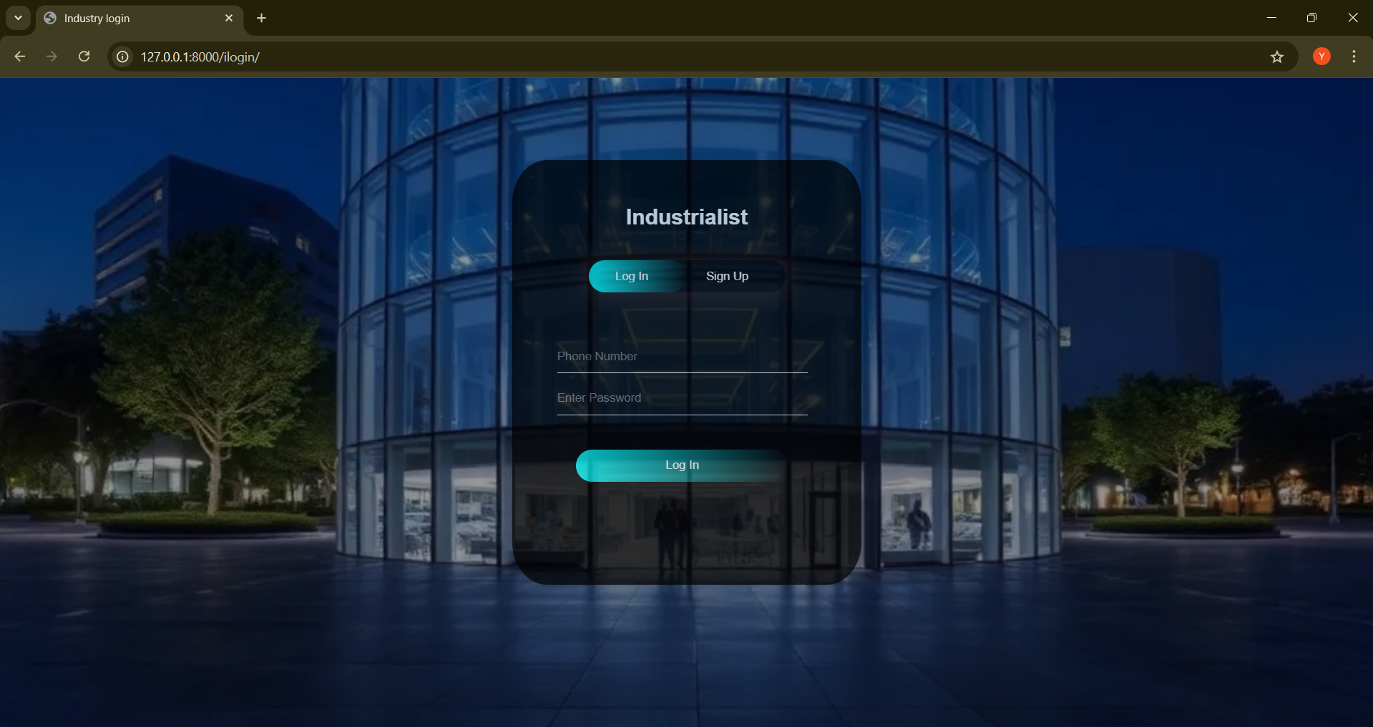

Figure 16: Industry Login Page

**Industry Page:**

**Requirements:**

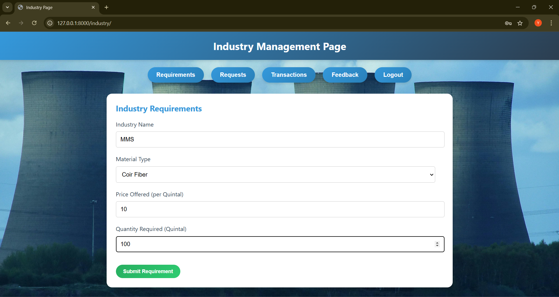

Figure 17: Industry Requirements

**Requests:**

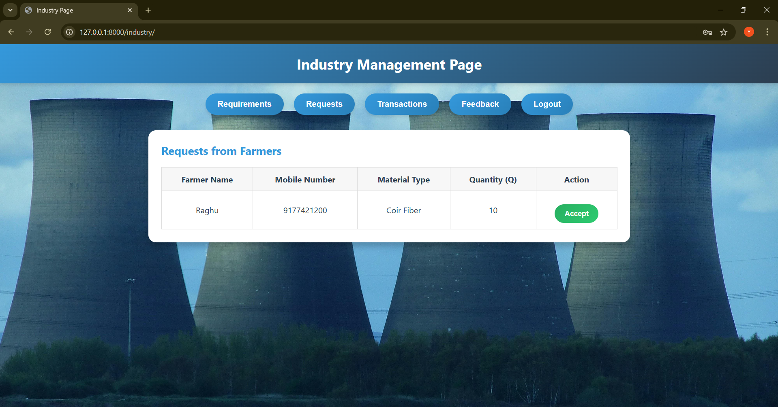

Figure 18: Farmer Requests

**Transactions:**

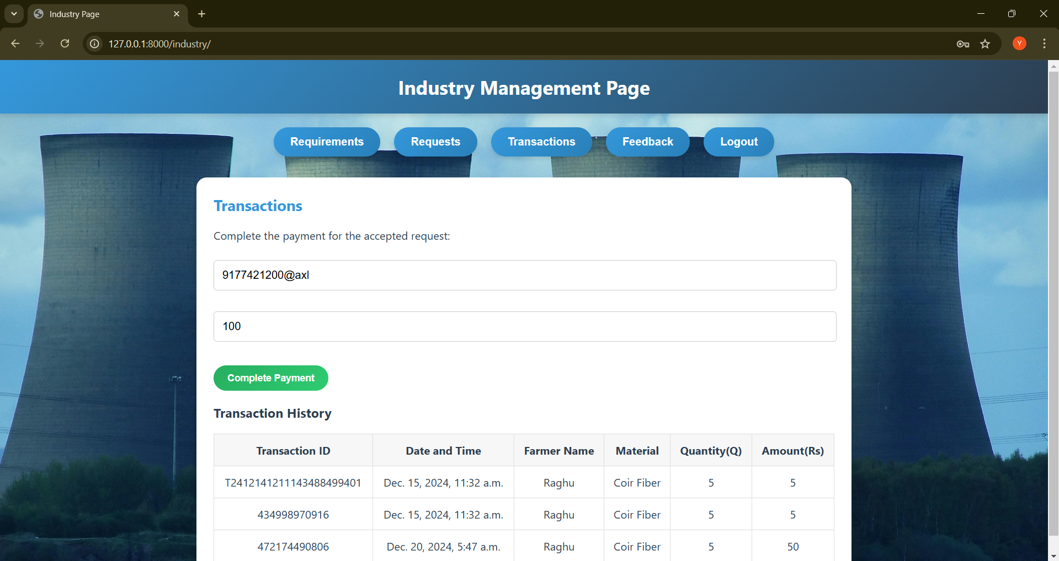

Figure 19: Industry Transactions

**Payment Page:**

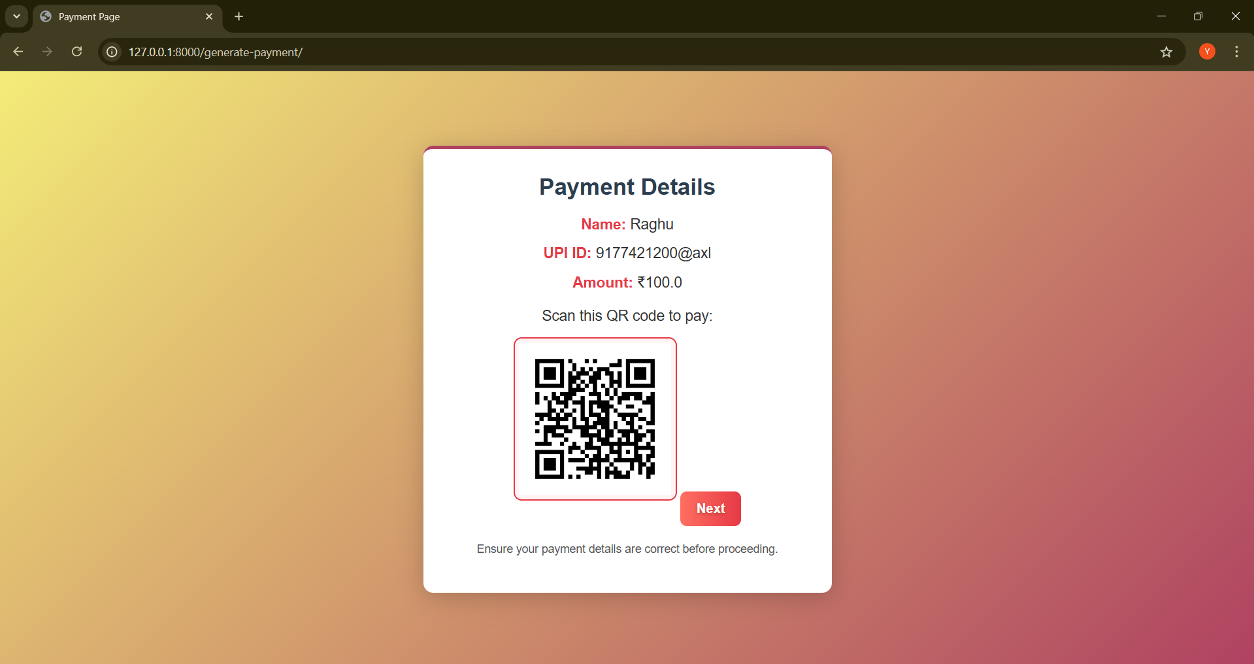

Figure 20: Payment Page

**Payment Confirmation Page:**

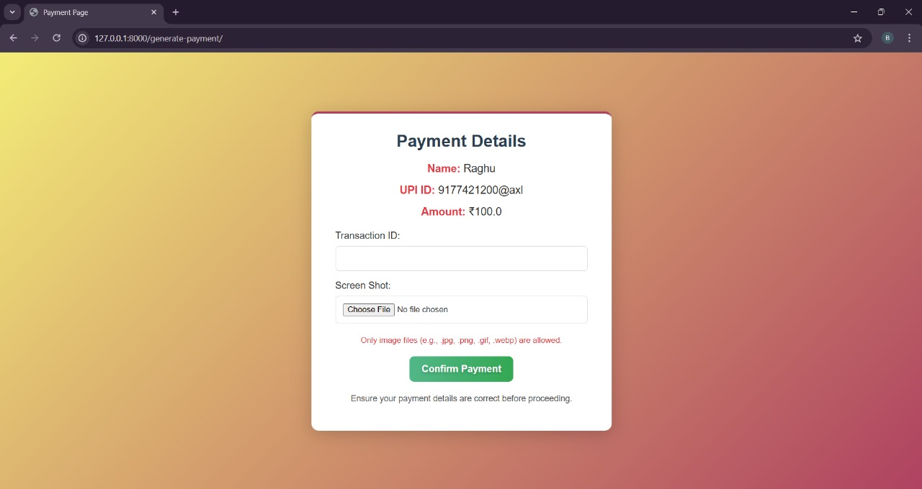

Figure 21: Payment confirmation Page

**Feedback :**

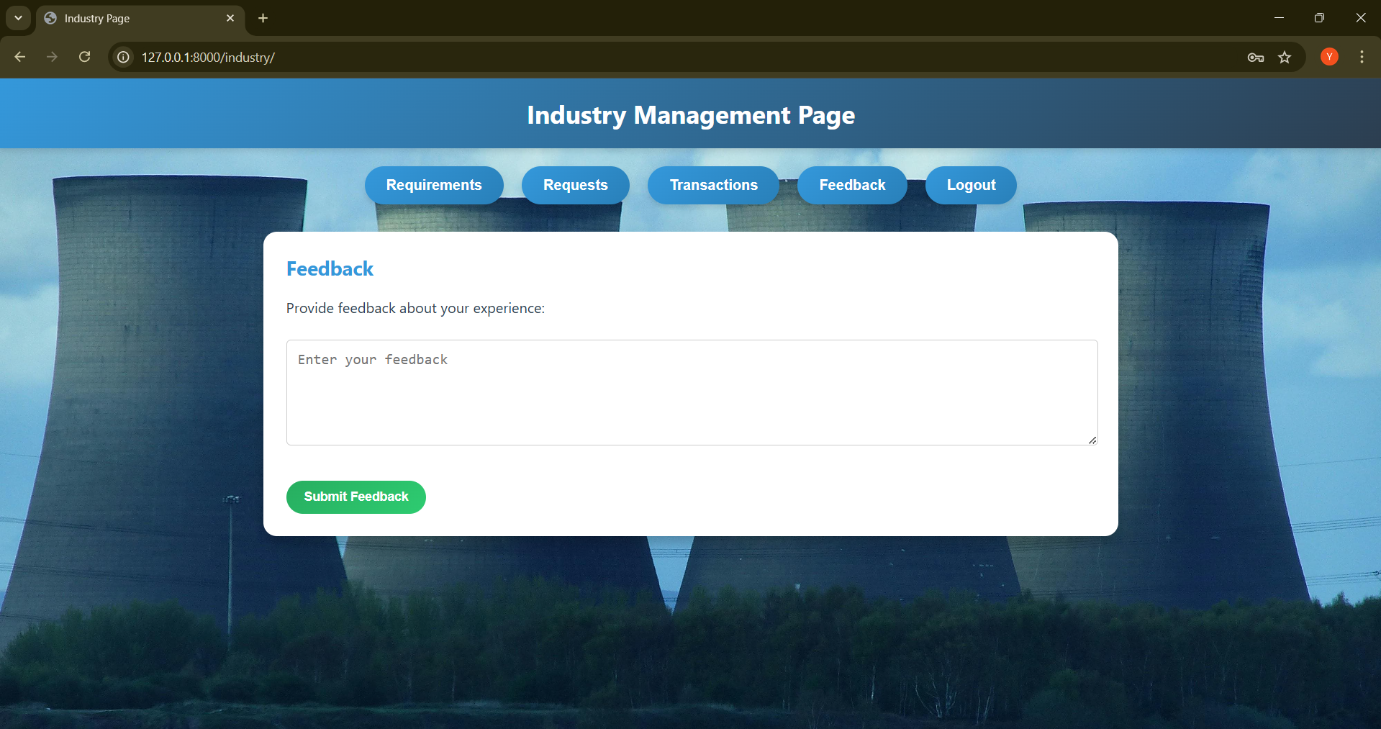

Figure 22: Industry Feedback

**Data Analyst Login Page:**

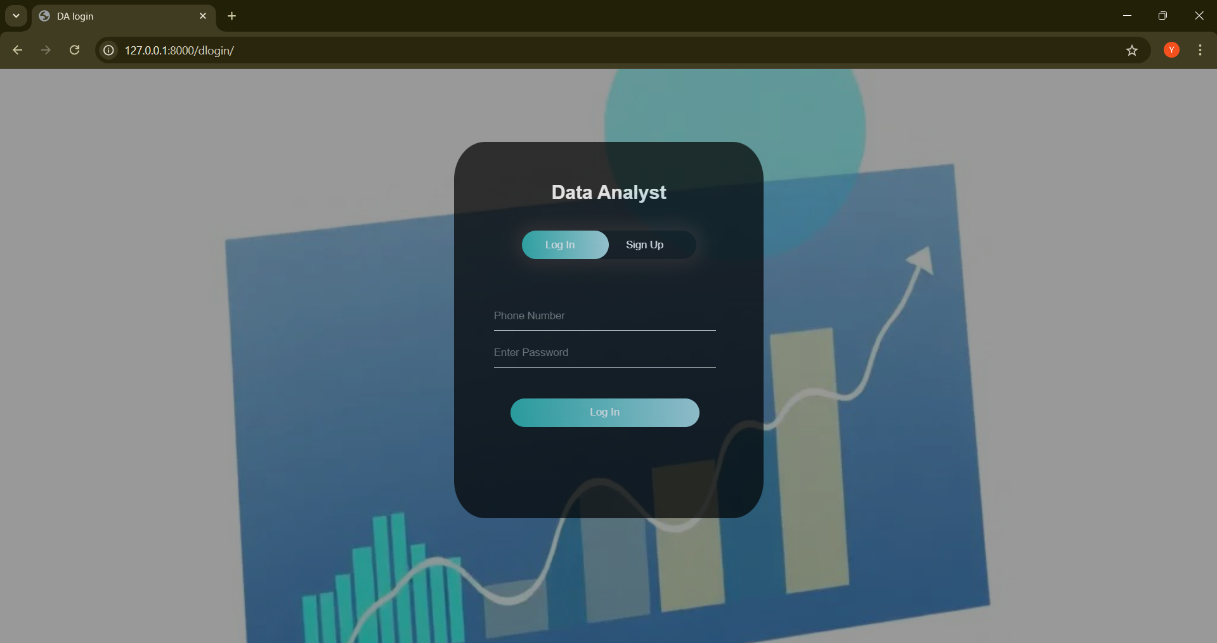

Figure 23: Data Analyst Login Page

**Data Analyst Page:**

**Transactions:**

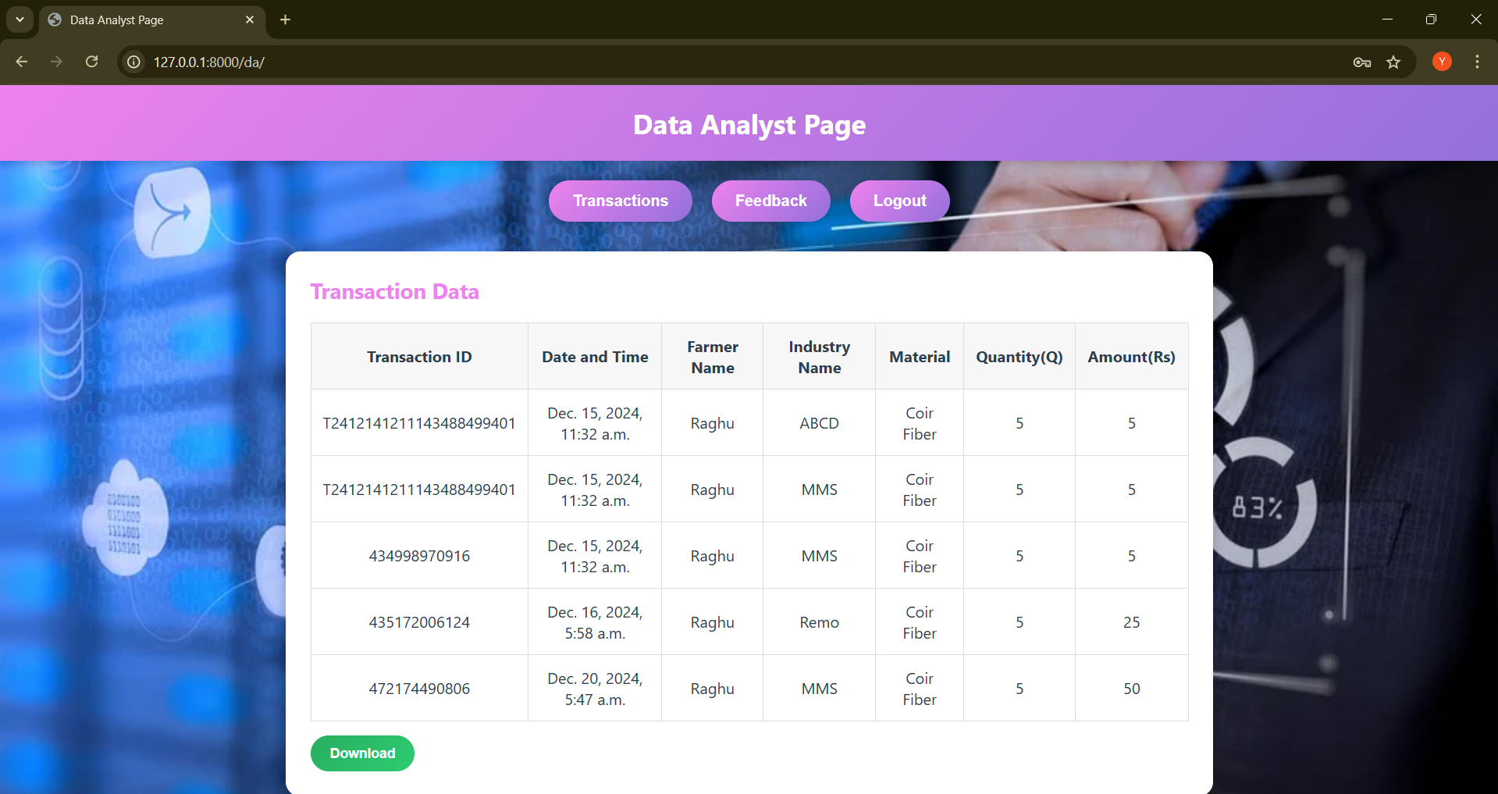

Figure 24: All Transactions

**Feedback :**

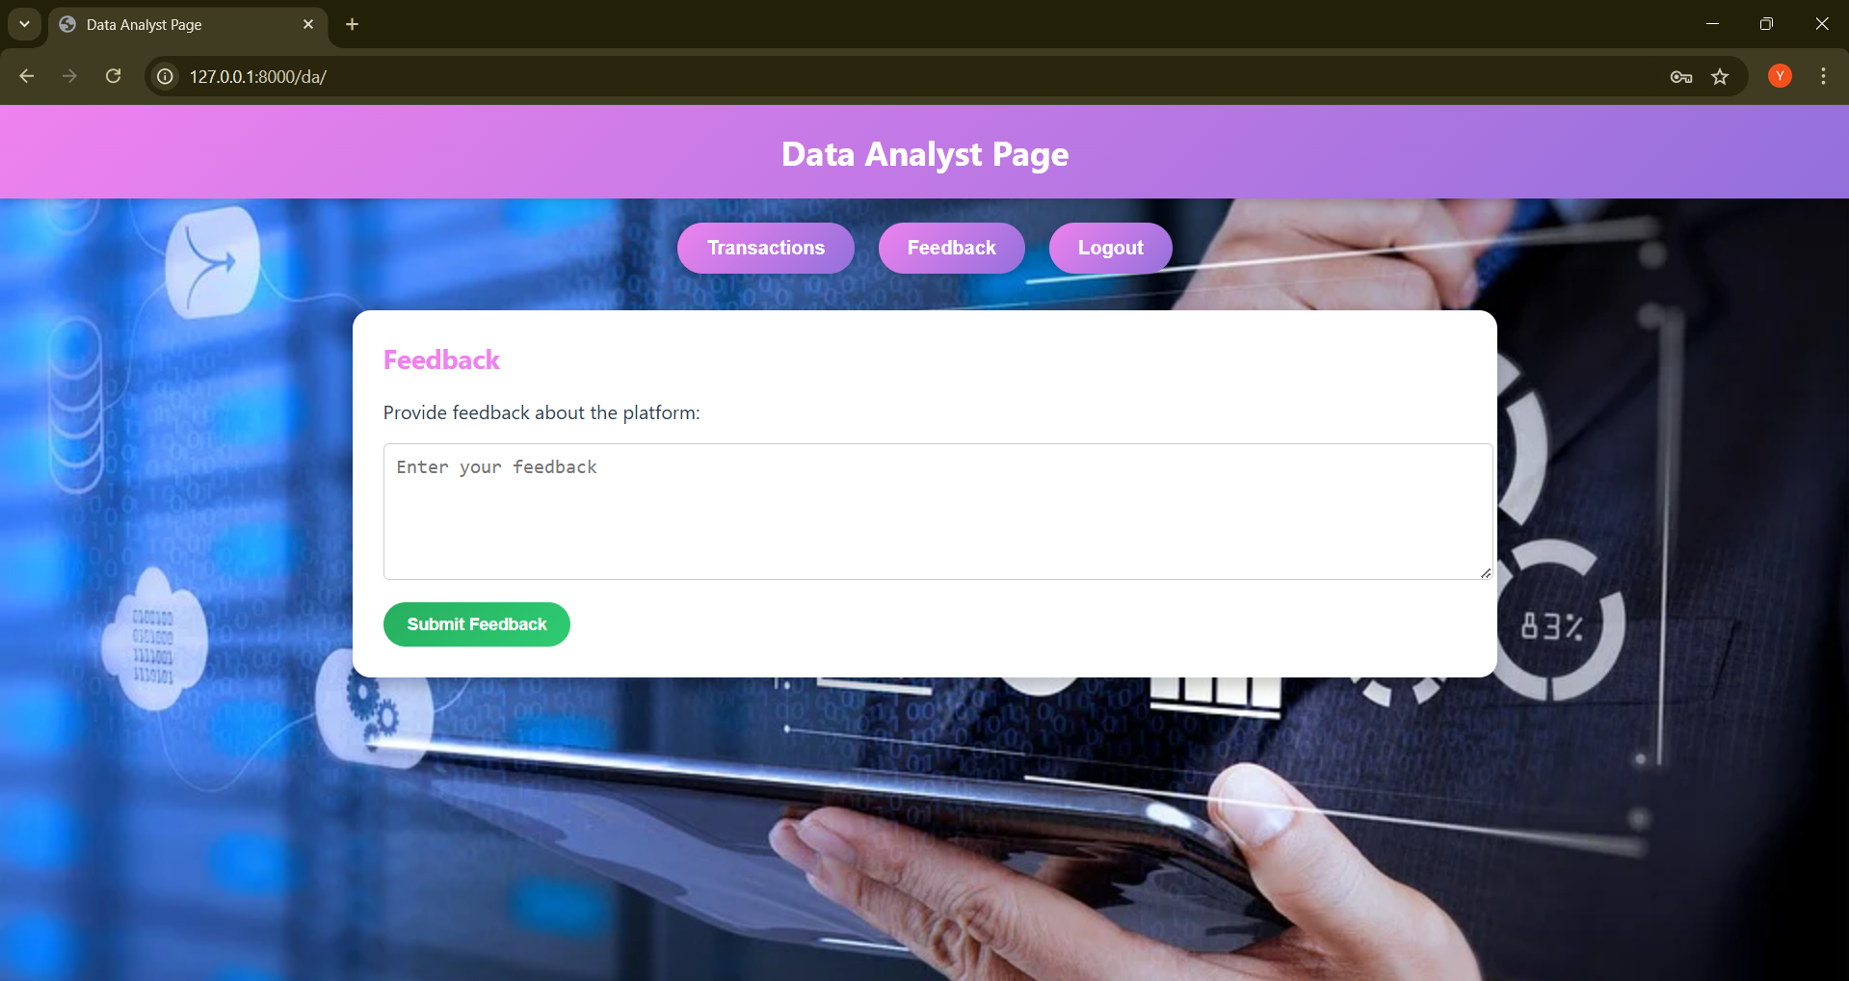

Figure 25: Analyst Feedback

**Admin Page :**

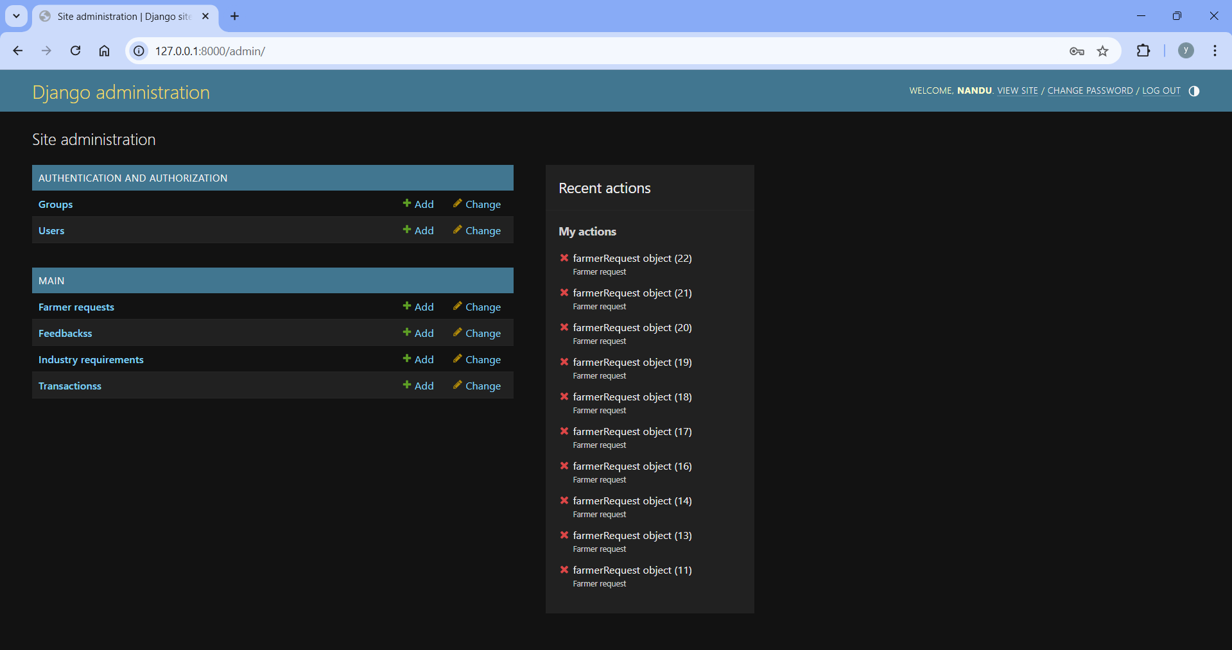

Figure 26: Admin Page

**APPENDIX-C**

**ENCLOSURES**

**JOURNAL PUBLICATION CERTIFICATES**

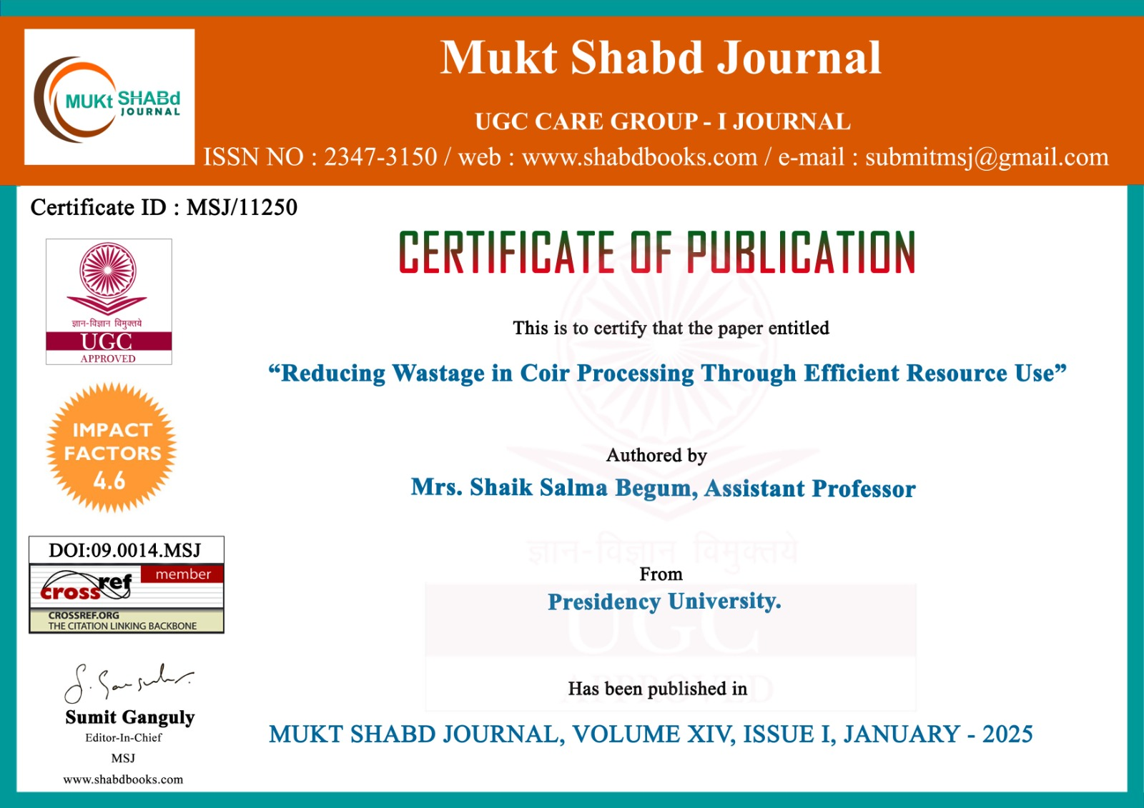

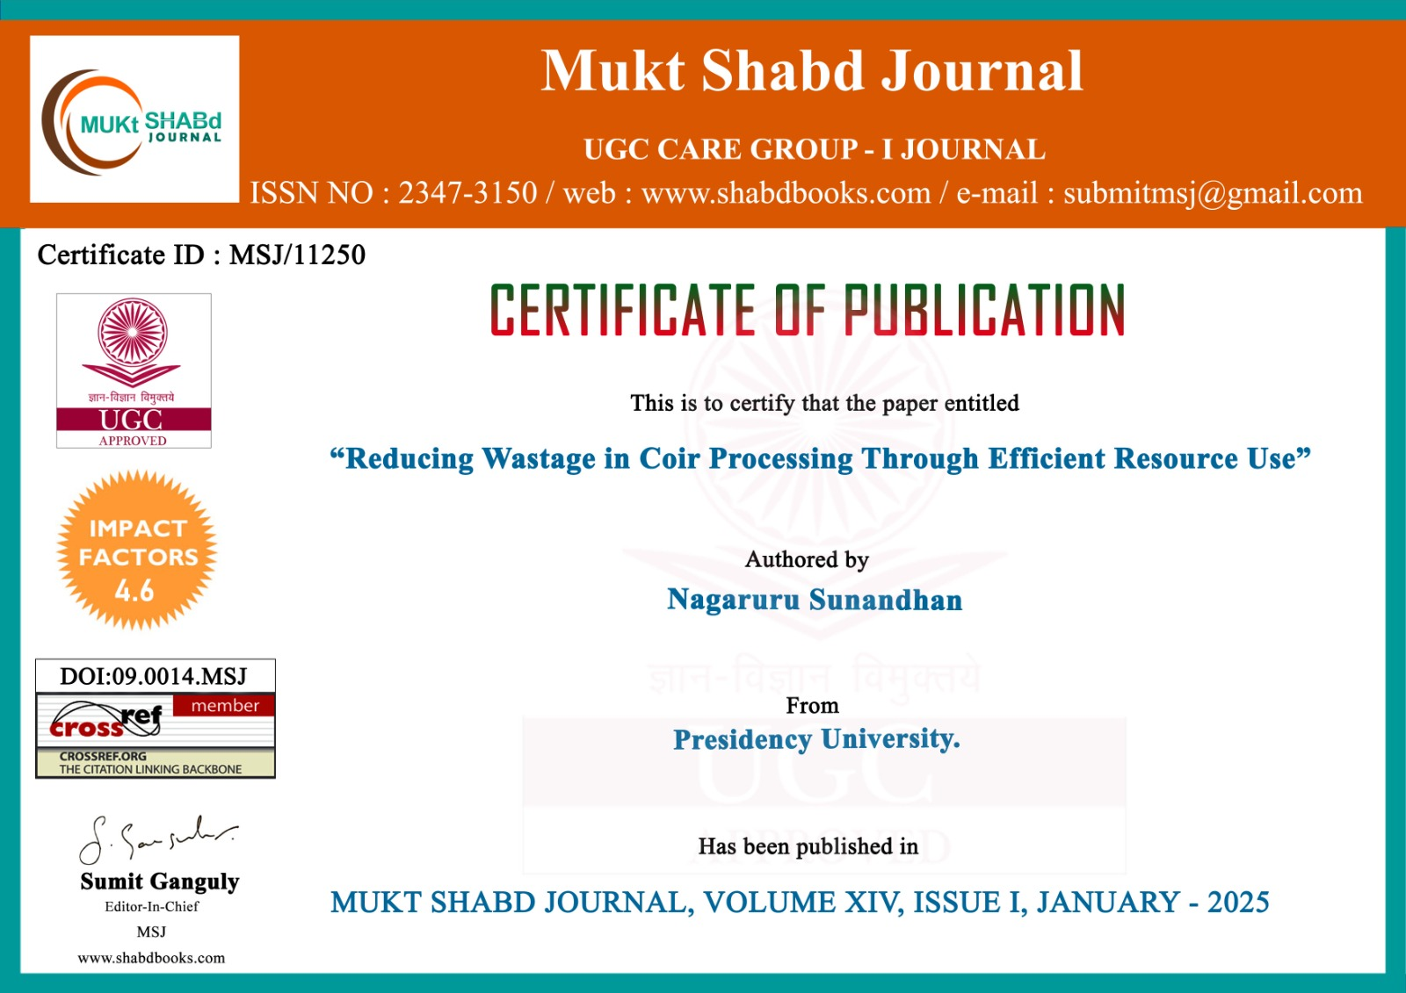

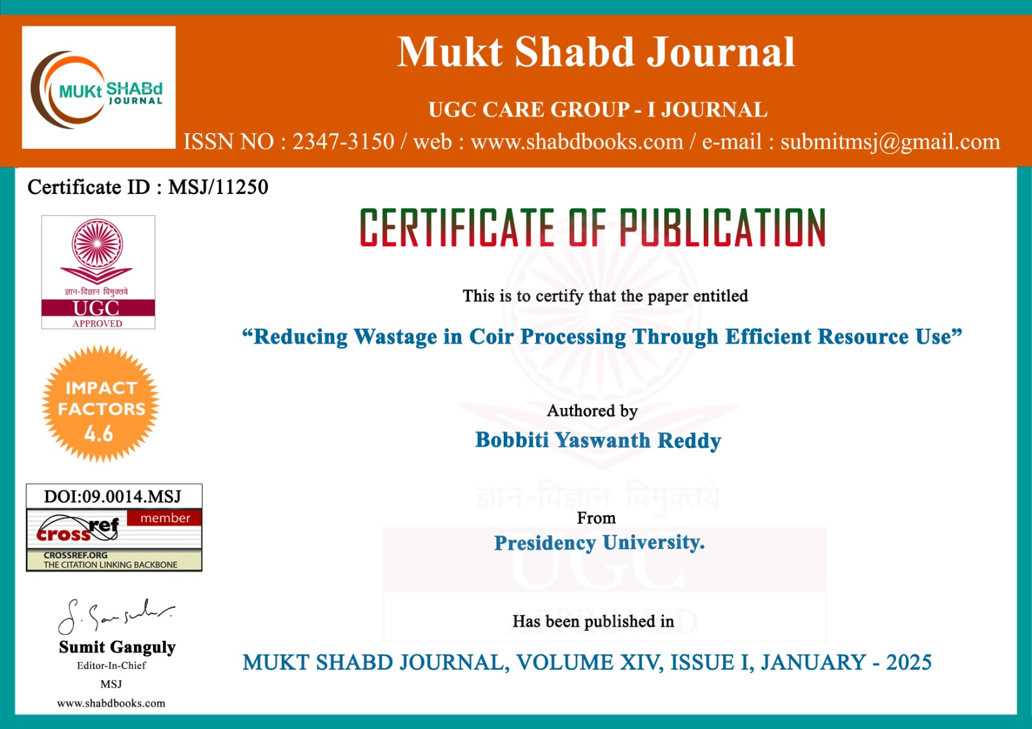

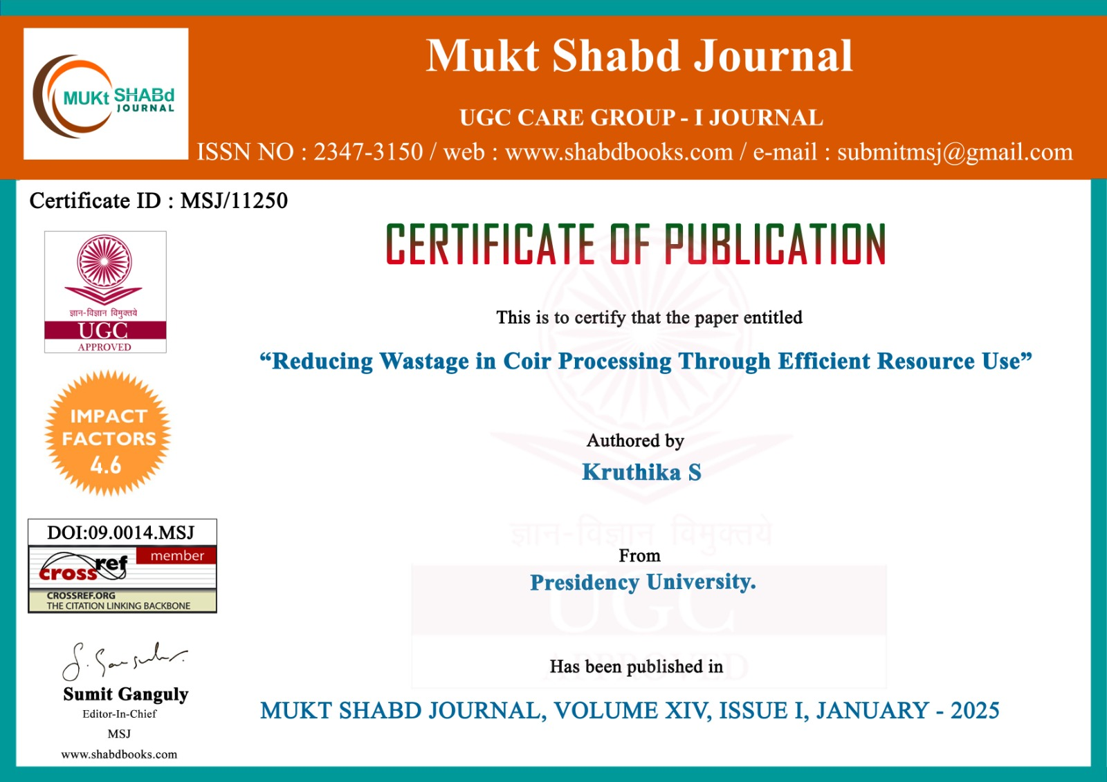

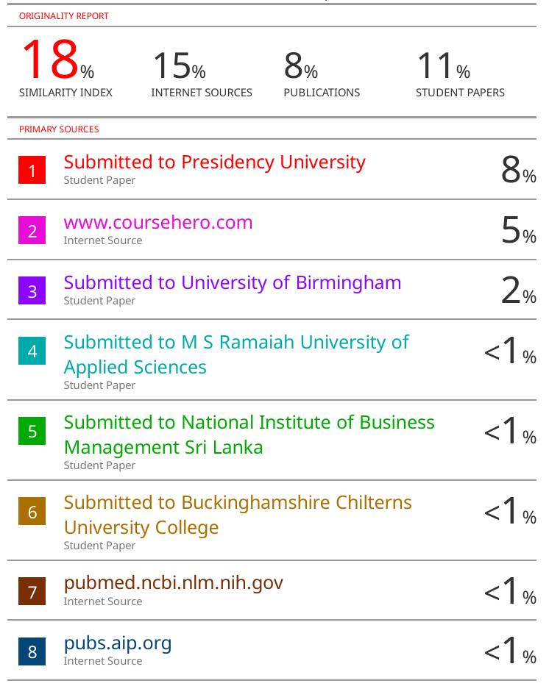

**Sustainable Development Goals(SDGs)**



* Provides coconut farmers direct access to markets, improving their incomes and reducing poverty in rural areas. (SDG-1)
* By increasing farmer revenue, the platform contributes to food security and promotes sustainable agriculture. (SDG-2: Zero Hunger)
* Encourages the inclusion of women in agriculture by providing equal access to the market and resources for female farmers. (SDG-5: Gender Equality)
* Promotes decent work by connecting small-scale farmers to larger markets, ensuring fair trade and economic growth in rural areas. (SDG-8: Decent Work and Economic Growth)
* Ensures efficient use of coir materials, minimizing waste and promoting sustainable consumption and production. (SDG-12: Responsible Consumption and Production)
* Helps industries adopt eco-friendly practices by making coir, a sustainable raw material, more accessible. (SDG-13: Climate Action)
* Facilitates partnerships between farmers, industries, and data firms to create a transparent, efficient, and collaborative ecosystem. (SDG 17: Partnerships for the Goals)